Make Ready.
OR, A Printer’s Manual for the Age of Mechanical Compositors; OR, How One Person and Several Tireless Machines May Keep a Small Press Honest; OR, Why Every Page Deserves a Witness That Could Have Said No
Clint Ecker
First edition, 2026
Table of Contents

Preface: the shop door
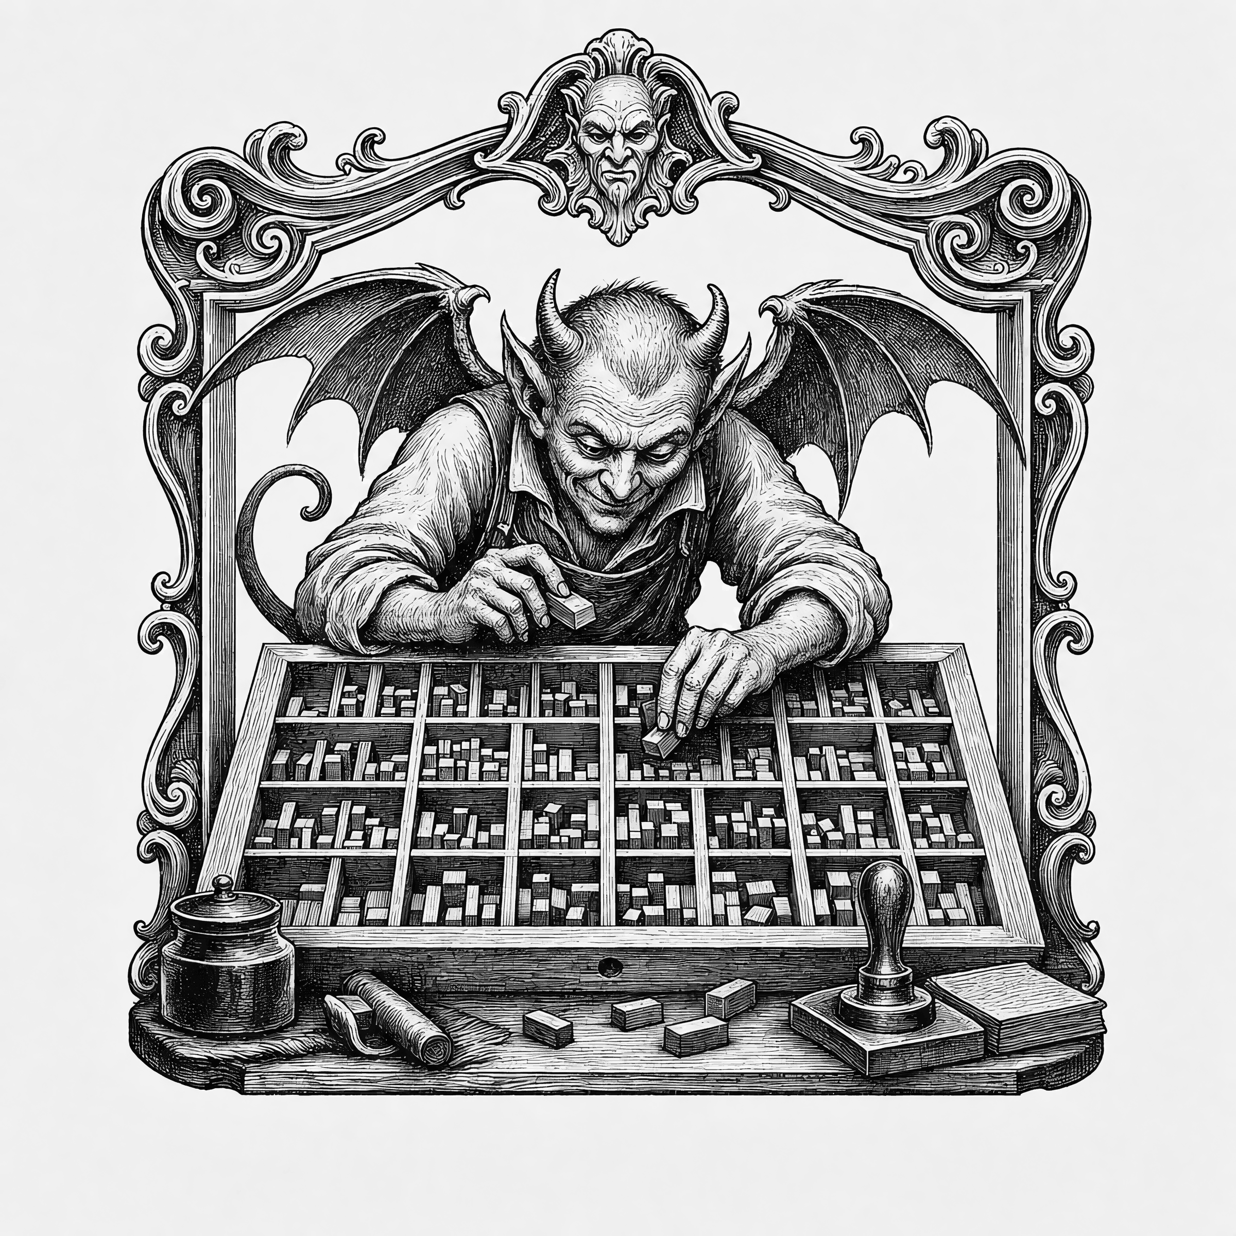
Titivillus at the frame, setting his favorite errors by hand. The motto above the case is the shop’s whole law.
The first person you met inside a Victorian printing office was usually the devil: the apprentice, black to the elbows, who fetched type, pulled proofs, mixed ink, and took the blame. Before a serious run the pressman spent hours in makeready, packing tissue under the low spots and easing the impression until the lightest hairline and the heaviest capital printed with the same even bite. Once a year the shop kept the wayzgoose, the printers’ feast.
I keep a small press now. One proprietor, no staff, several machines that compose, impose, proof, and bind without getting tired. When I started working this way I went looking for new words for it. I did not need any. The thing that sets my pages works fast and gets things wrong in ways I have learned to expect. That is the devil. The box where the shop keeps every page that has ever lied, so the proof-readers can be made to catch each one again before they read anything real, is the hell box. The hours before a run, when nothing ships, are still makeready. Even the wayzgoose survives, because a shop this small forgets to celebrate unless the feast is on the calendar.
The old vocabulary fits because the old problem is the same. Printing was among the first mass-production crafts to make verification a standing, salaried stage of the work. A good compositor set type by the thousand ems, far too fast for anyone to check him letter by letter. So the trade built the proof, the copyholder reading the manuscript aloud against the galley, the revise that showed each correction had actually been made, the sheets pulled and read before the full run went on. Fast, fallible labor at every stage, and a second pair of eyes after it. The trade never solved the compositor; it surrounded him.
This is a working manual, not a history. Each chapter teaches one practice of the modern shop: how to write the copy the devil composes from, how to work the devil without trusting it, how to make ready the hell box that proves the proof-readers before they read, how to pull a proof you did not set, how to impose the sheets and brief the plates, how to know when the forme may be locked and the run declared good. Where the old trade had a rule, I give the rule and then what it looks like at my bench today. Every practice here has been paid for in my own shop, usually by skipping it first and paying for the reprint. Anything I have not paid for myself I left out.
You already know how to build software. What changed is the shop. You direct labor that is faster and cheaper than you and wrong often enough to matter. The printers organized their whole trade around labor like that. They did not slow the compositor down, and they did not stand over his case watching every sort he lifted. They made someone read the sheets before the customer could.
So the door is open. The whole book is commentary on one rule: every page deserves a witness that could have said no.
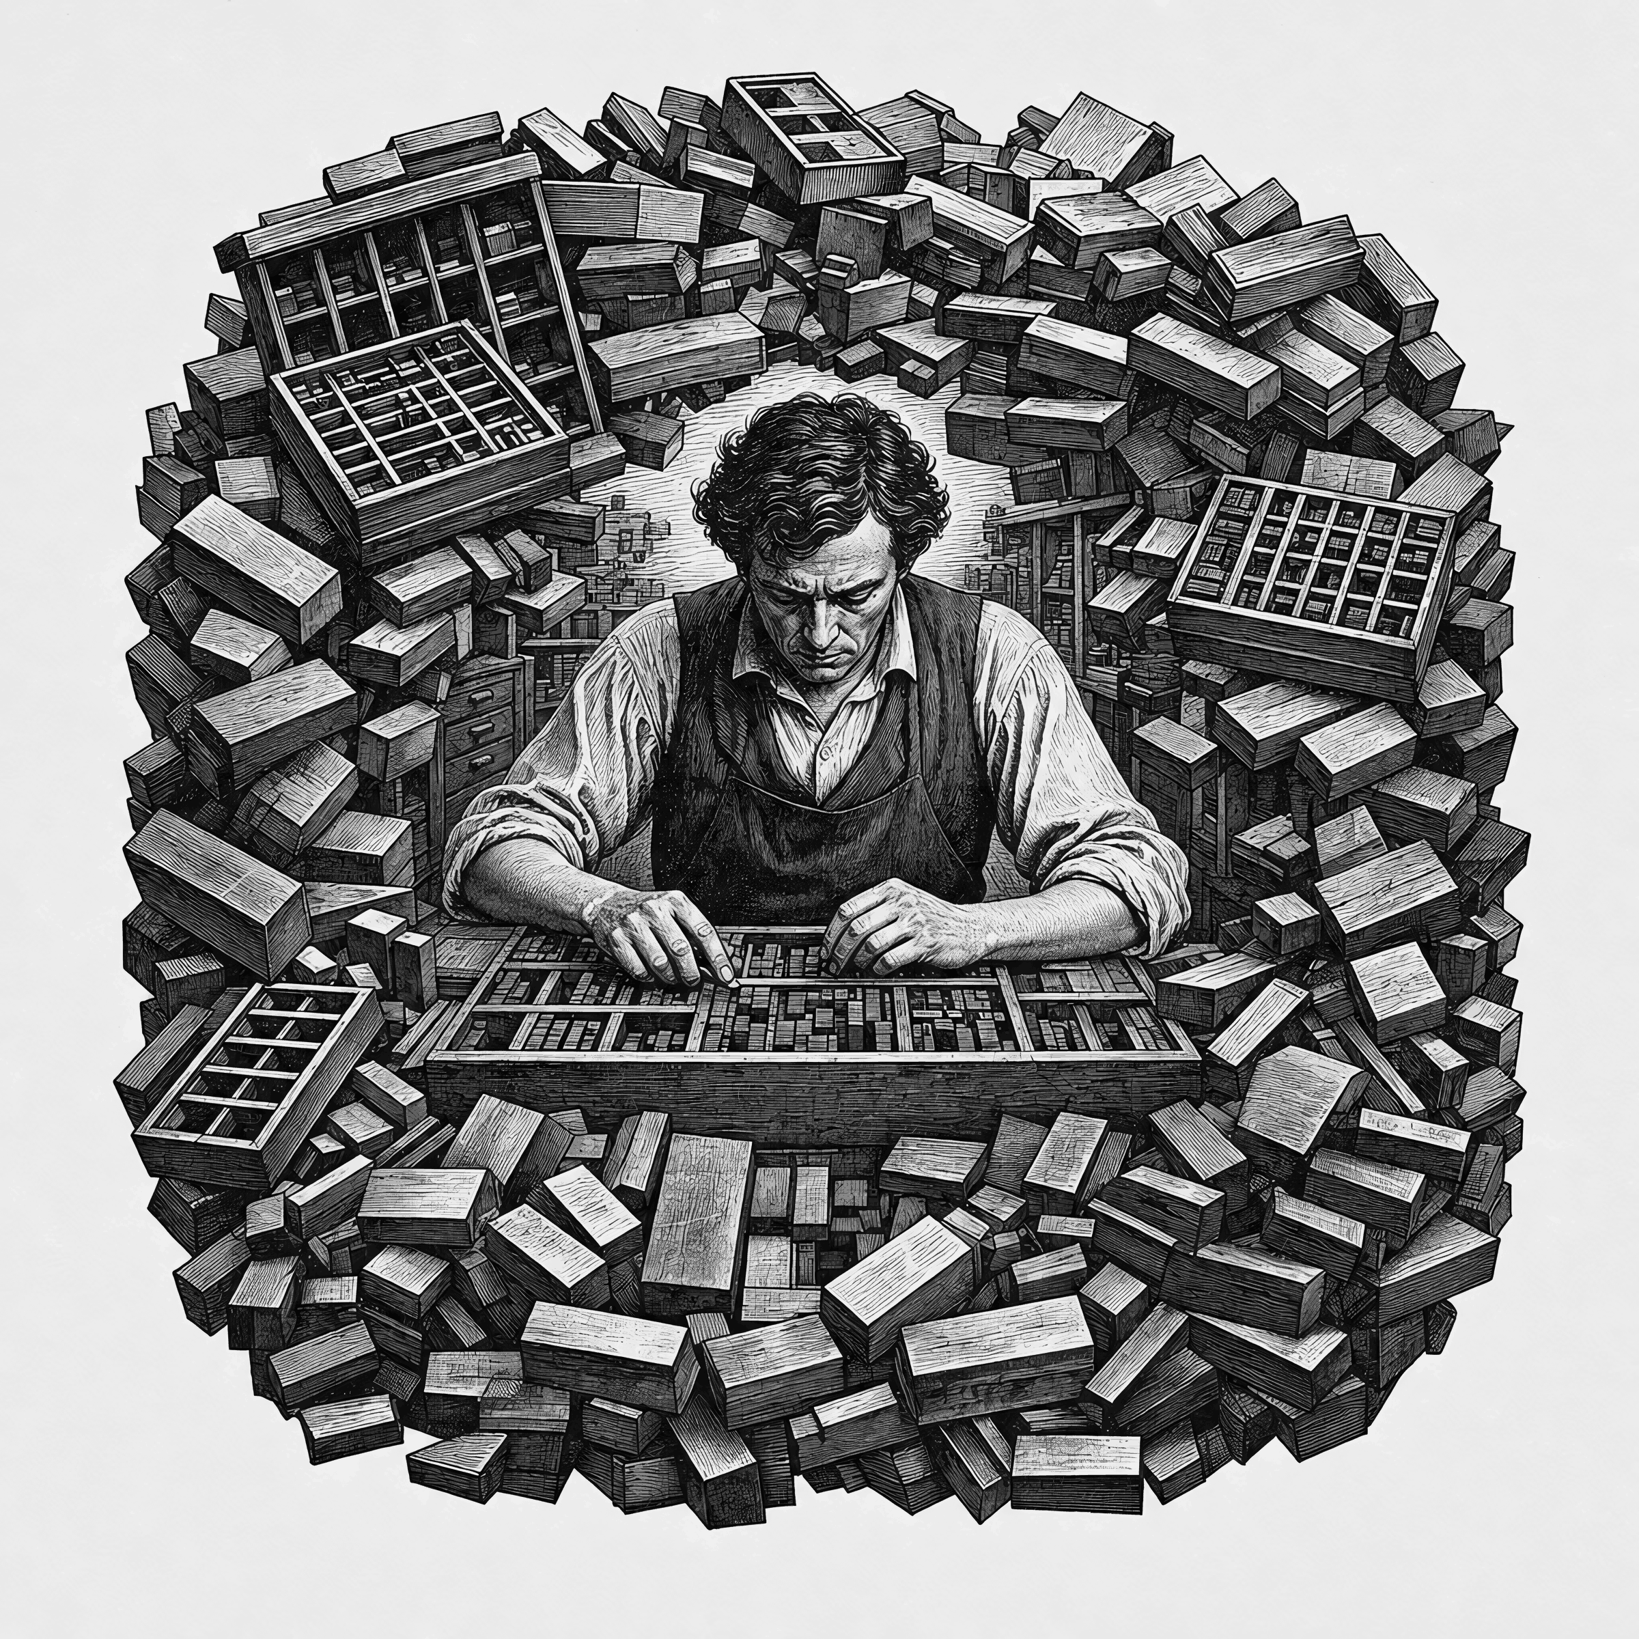
The trade never solved the compositor; it surrounded him.

1 The shop
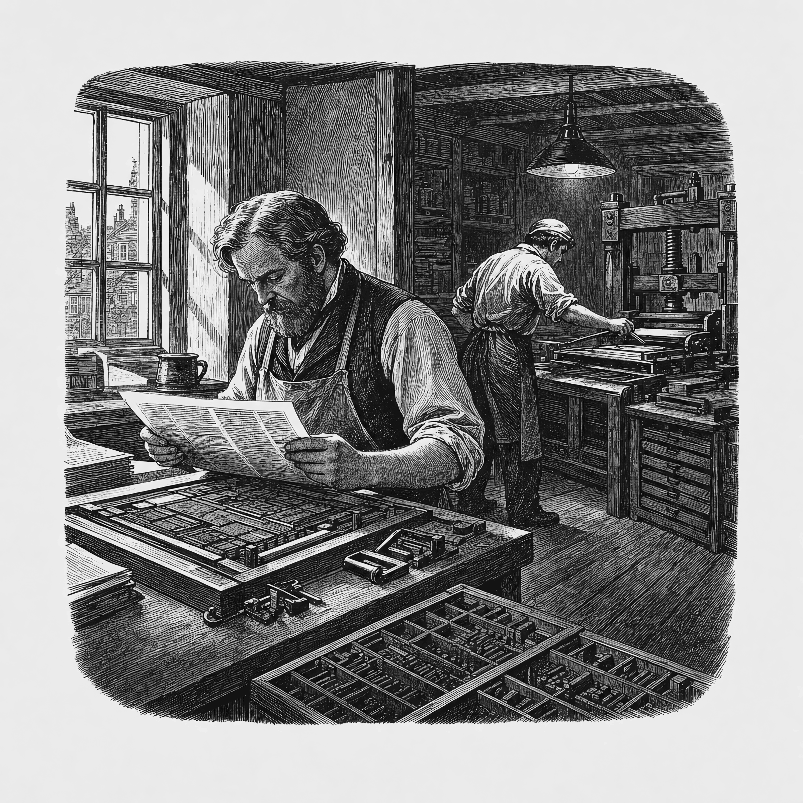
The shop at morning. The proprietor reads what the night shift set; the night shift has already begun the next.
The old printing houses were built around one scarcity. Type went into the composing stick by hand, letter by letter, out of a divided case, and even a fast compositor got only a few columns from a long day at the frame. A shop that wanted more pages hired more fingers. The case room grew sideways, frame after frame. The reading closet stayed a closet, because one proof-reader with a boy to hold copy against him could keep pace with the whole floor. Setting was the slow part.
Then the composing machines came into the trade and the scarcity reversed. An operator at a keyboard set several times what a hand compositor set, and the machine did not slow in the afternoon. Setting turned cheap in a single generation. The choke point moved to the closet nobody had thought about, where proofs now stacked up faster than any reader could honestly work through them. Some houses noticed and rearranged themselves around reading. The rest went on shipping errors.
This book is a manual for a shop built after the reversal. It is a small shop. It is probably you and nobody else, or you and one or two partners, and it produces serious work: software people rely on, sometimes books. Everything in the chapters ahead follows from the arrangement described in this one.
Start with the machines. Several of them work here, and together they are the devil, whose chapter is coming. The devil is quick, tireless, willing, and not answerable. It works all night. It does what it is told, and it does things it was not told to do. Without its speed there is no shop, and nothing about the speed makes the work correct.
Hold on to one piece of arithmetic: the devil can set more type in an hour than you can read in a day. Practice will not close that gap, and next year’s devil widens it. So capacity, the thing every shop in history was starved for, is now cheap, and the scarce thing is authority: one person’s considered judgment, with a name attached, that this work should go out.
From that, the first law of the shop: nothing reaches a reader on capacity alone. Every path from the devil to the door passes through something with the standing to say no. Most of those gates are machines. The last one is you.
The devil takes everything whose correctness another machine can check. Save your reading hours for questions no gauge can settle. Whether the code compiles, whether the tests pass, whether the build reproduces, whether the output matches the specimen, whether yesterday’s behavior survived the night: machines answer all of those on every run, without you. Building the gates is itself much of the devil’s work, and it is good at it; a devil will happily forge the jig that catches its own errors. A check that takes four seconds can afford to run a thousand times a week.
You keep three things. Taste: whether the work should exist in this form at all, which no test can hold, because taste is a judgment about readers. Consequence: what happens to a particular person when this particular thing is wrong, and whether that price is yours to offer. And the signature. Old law required the printer’s name and address on everything that left the shop, so that someone could always be found and held to account. That statute has lapsed, but a customer with a broken install still wants a person, and the devil has no name a court or a customer can use. The name they get is yours, whether you print it or not.
The signature is also why the shop stays small. Machine-checkable work scales with the devil; take on as much of it as it can gate. Judgment does not scale. A jig can hold a gauge against ten thousand sheets, but the title page still has to be passed by a person, and the person is you. Each product, each audience, each promise no machine can vouch for adds one more spot on the floor that only you can occupy. Take on too many and you are running between the spots, glancing where you should be reading.
Here is the working day.
Morning is for reading. The devil worked the night, and the proofs are waiting: galleys of new work, corrected pages, reports from the overnight runs. Read the reports first. A clean report costs you ten seconds; a red one tells you where the morning goes. Then read the work itself. Whether it finished is the machine’s question, already answered. Yours is whether it is right, and whether it is good. Mark what needs another pass. Kill what deserves killing, without ceremony. Setting is cheap now, and the worst habit the old scarcity left us is reverence for work merely because it exists. A galley is not owed a place in the forme.
Afternoon is for setting new work, which mostly means writing copy. The devil sets what you give it, so give it copy worth setting: what to build, for whom, which parts must be exact, and framed so that a machine can check as much of it as possible. Phrase a requirement as a gate and you never have to read for it again; the hour spent making copy checkable comes back all week. Standing over the devil speeds nothing up, so hand the copy over and go do something else.
Evening is for pulling the run. Build everything, end to end, in the form a reader will receive it, and run every gate. Then open the finished artifact yourself: install the release, load the pages, the whole object, not just the diff. Most evenings this takes half an hour and tells you tomorrow’s reading will be routine. Some evenings it tells you the run does not go out. An unshipped run costs you one night. A shipped error has to be chased through doors you cannot see.
Then you stop and the devil does not; it is back at it by midnight. Let it run. Everything it sets tonight arrives tomorrow as proof, and proof is all it is until you have read it and signed. The chapters ahead take up the copy, the devil, the gates, the reading, and the pull, in the order the work moves through the shop.

2 Copy
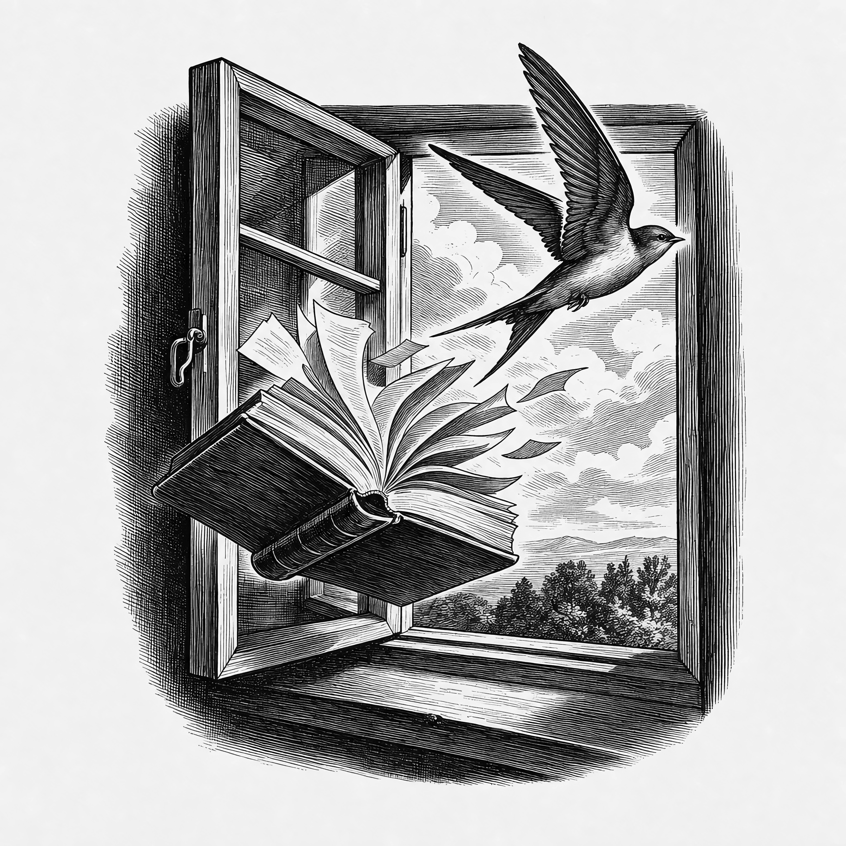
Follow copy, though it fly out of the window.
The hand compositor did not work from the author’s intentions. He worked from copy: the manuscript, read and marked for the shop, cut into takes by the overseer, and hung on a hook where the man could reach it. The standing instruction in every shop was “follow copy,” and the old hands stretched it into a joke: follow copy though it fly out of the window. A shop where each compositor improved the text as he set it would print a book that nobody wrote.
So there was one copy, and it was law. In the reading closet the copyholder read the manuscript aloud while the reader followed the proof, and where the two differed, the copy won. When an author changed his mind on a proof, the shop charged him for the alteration; he had departed from copy. The marked proof then became the copy for the next pass. There was never more than one authority, and everyone knew where it hung.
Two authorities agree on the day you create the second one and on no day after. Someone corrects the proof and forgets the manuscript, or corrects one take and not its twin, and from then on the shop holds two versions and can prove neither.

2.1 Nothing stated twice
My shop keeps the same law with different furniture. The copy is a folder of chapter files. Everything a reader ever touches, the print pages, the screen edition, the pages on the web, is set from those files by the frame, the standing build that composes every format from the one manuscript.
The law reads: never state a fact a second time that the frame could derive. The title of this book appears in four places: the cover, the half title, the running heads, and the notice of each edition. It is written once, in a small file the frame consults, and set everywhere else by machinery. Write it by hand in a second place and the two agree for a while. Then a retitle touches one and misses the other, and the shop has two titles.
Derivation makes the disagreement impossible instead of unlikely.

2.2 The shelf orders itself
The reading order of the chapters is recorded nowhere. Each chapter file carries a number in its name; the frame sorts the names, and the sorted list is the book. There is no contents page kept by hand, no manifest.
A manifest would be a second copy of the shelf. It agrees on the day it is written. Then someone renames a chapter file, or slides a new chapter between two old neighbors, and the manifest goes on swearing to an order that no longer exists. The shelf cannot be wrong about its own order. When you want a fact, take it from the thing that owns it.

2.3 An index that cannot lie
The index is mined from the text on every build. I pick the terms worth finding; the frame reads the whole manuscript and locates their pages. The index cannot disagree with the book, because it has never seen anything except the book as it stands this minute. An index kept by hand starts disagreeing at the first revision and never stops.
The harder case is a curated term that matches nothing. The comfortable design would skip it quietly and print the entries that still work. This shop fails the build instead, and the failure names the term. A dead entry does not stay hidden. One reader follows it to a page that says nothing of the kind, and after that he doubts the rest of the column. So when a revision wears away the phrase a term depended on, the build stops and makes me choose: restore the phrase or retire the term. Either answer is fine.

2.4 The ledger is the notice
The shop keeps a ledger of editions. Every change goes in as it is made, one plain line under the heading of the edition to come: what was added, what was fixed, what was removed. When the edition ships, that section of the ledger becomes the release notice, word for word. Nobody sits down to write the notice. It was written all along, in the tense of work being done, by whoever did the work.
The notice cannot flatter, because nobody composes it. A summary drafted at release time remembers the additions and forgets the reversals. A ledger line written the hour a defect was fixed says “fixed” and names the defect. Copy the ledger in verbatim and the customer reads what the shop recorded for itself.

2.5 Generator, checker, convention, memory
The devil is what makes this law urgent. Ask it to add a chapter, and if the shop keeps a hand-made contents page, a hand-kept index, and a drafted notice, it will cheerfully update all three, each a little differently, each version plausible on its own. It copies eagerly and never quite the same way twice. You will not catch this by reading harder. Leave it nothing to copy. Where a fact lives in one place, the devil can only get it wrong in one place, and one wrong place is what the frame is built to catch.
When a fact truly cannot be derived, rank the ways of keeping it: prefer a generator to a checker, a checker to a convention, and a convention to a memory. A generator produces the artifact, so the artifact cannot disagree with its source. A checker complains only after the disagreement exists, and only about disagreements someone thought to check for. A convention is followed until somebody has a busy Tuesday, and it fails without a sound. Memory is worse. Every step down the ladder trades a machine for a person paying attention.
The old shops ran the whole of this with one hook and one standing instruction. There was one copy, and it was dear. Everything else was proof, and proof was cheap: pull it fresh, mark it up, throw it away. The copy still hung where it always hung, and the next pull would be set from nothing else.

3 The devil
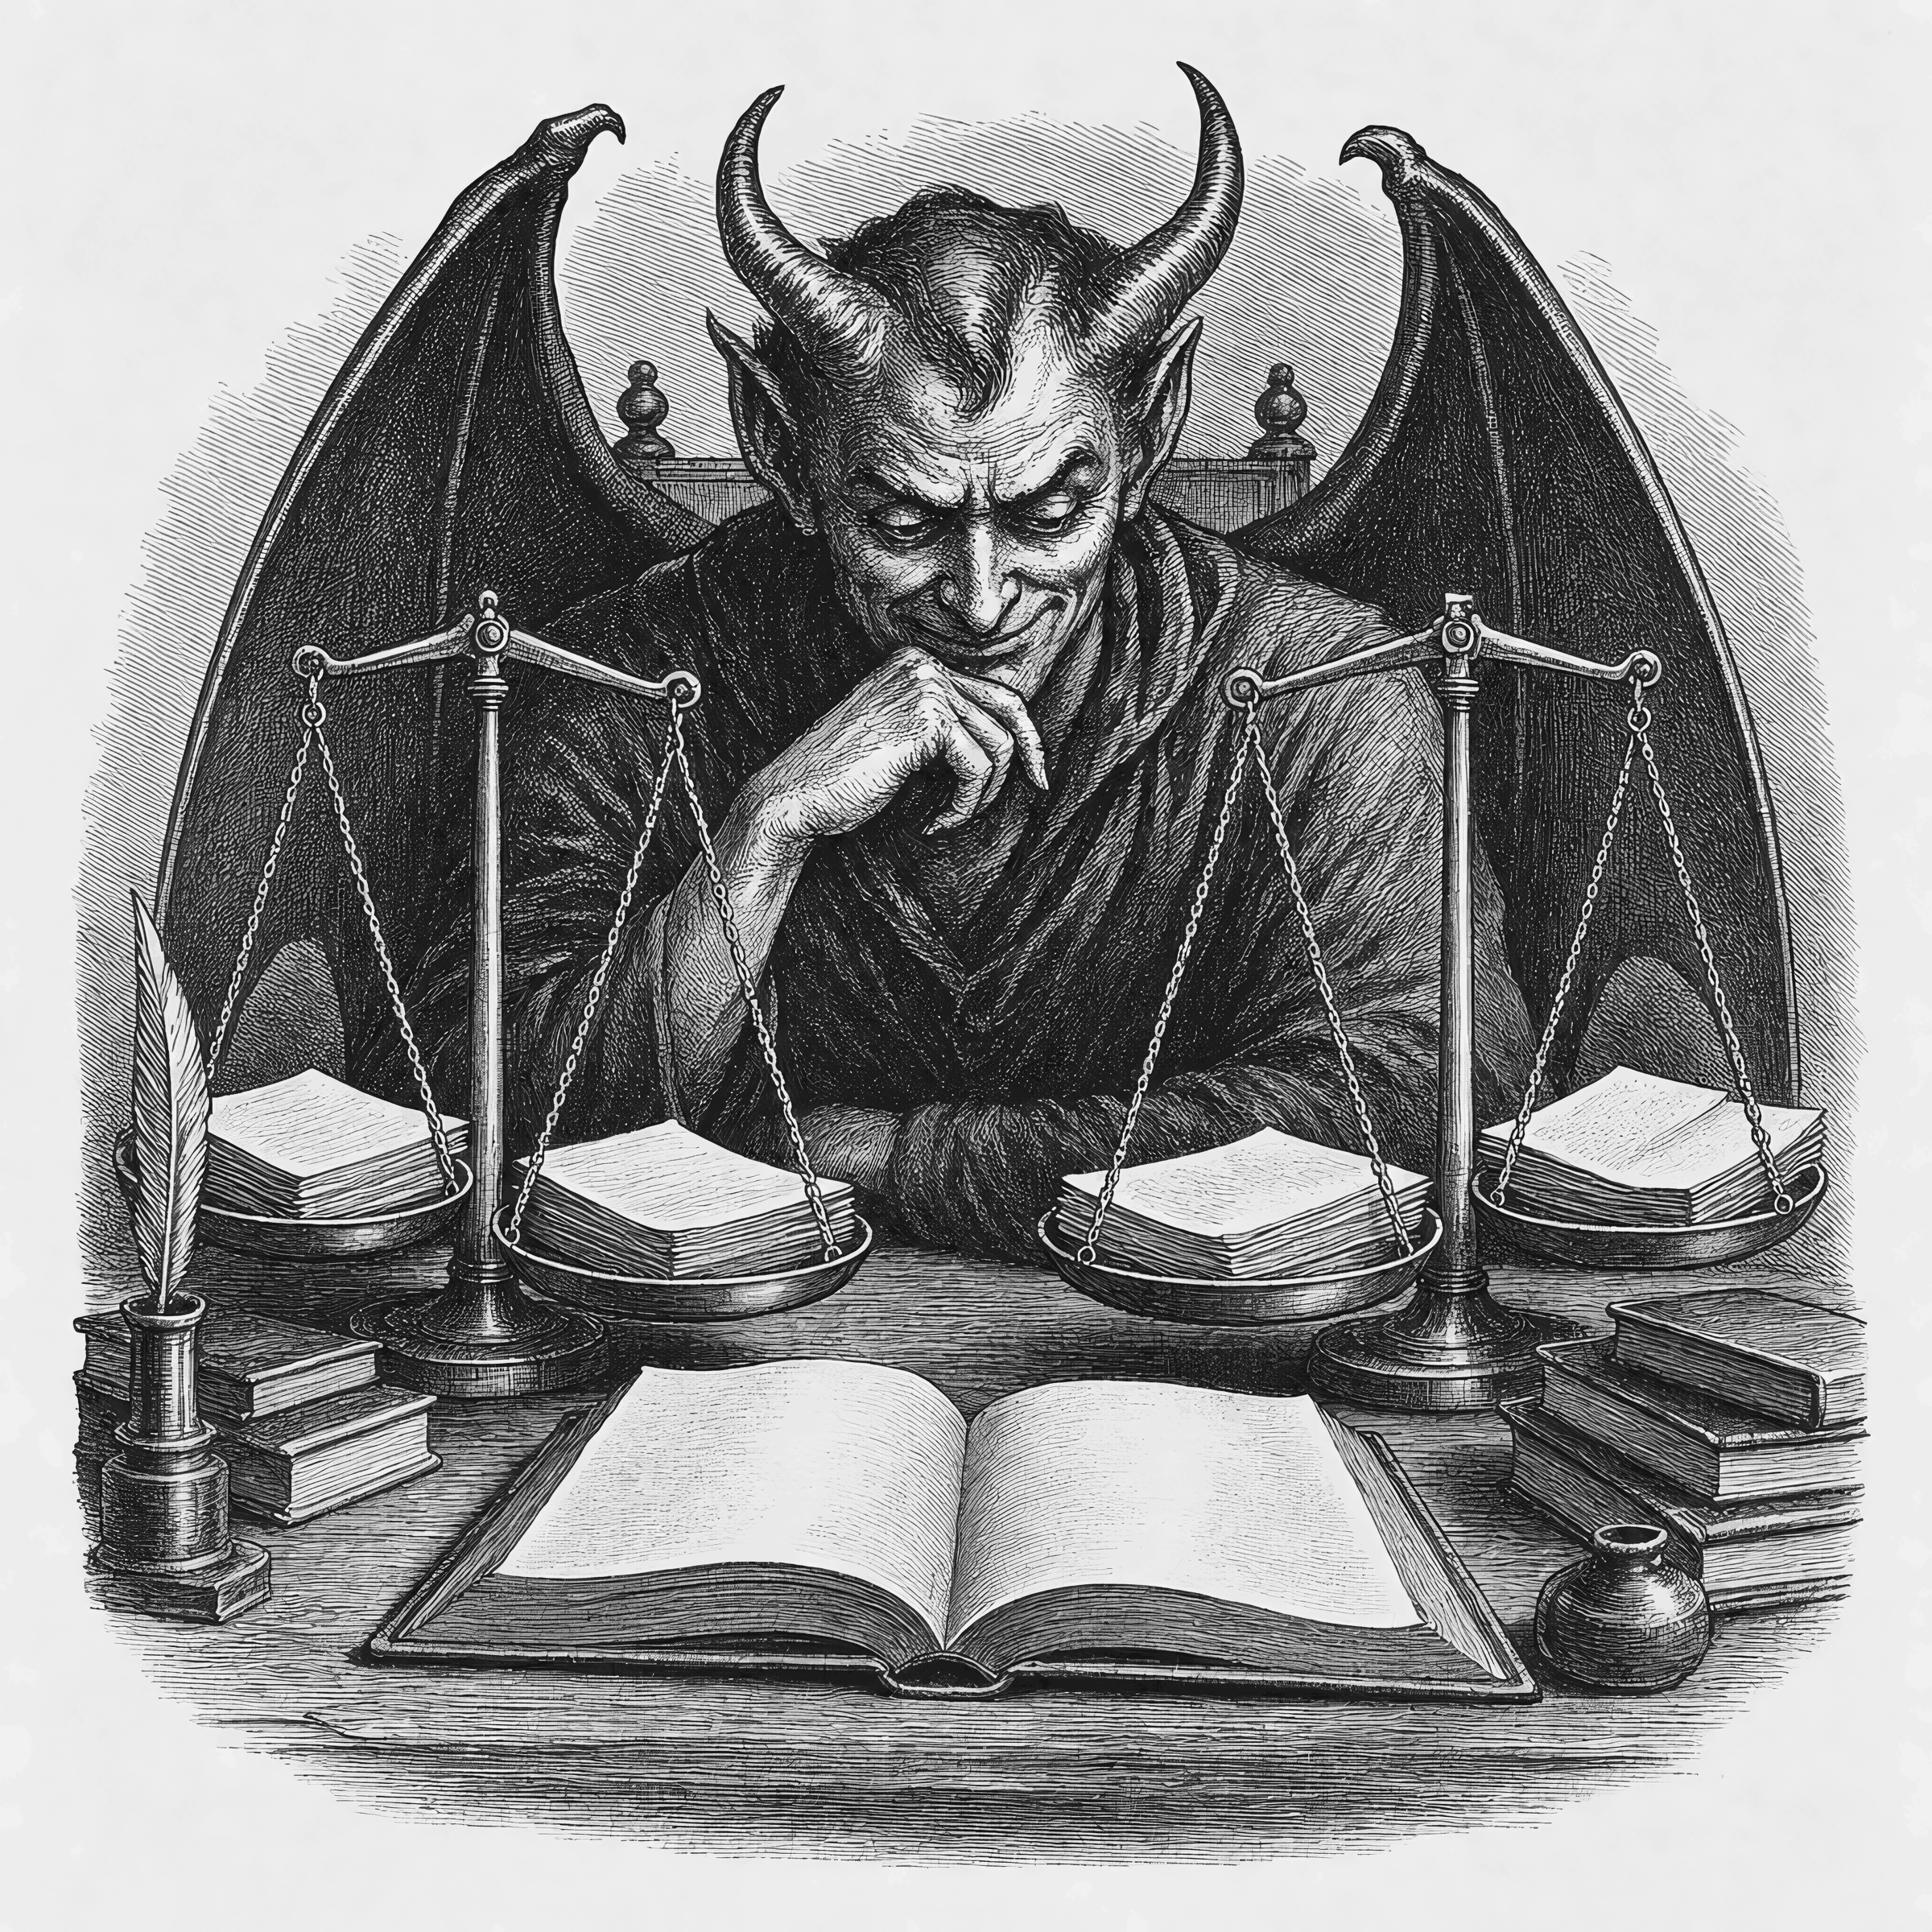
The devil at his case. The copy says “peace”; his proof says “pace”; and the setting is so true that neither looks wrong. That is the whole danger.
The youngest hand in a letterpress shop was called the printer’s devil. He swept, he fetched, he inked the formes until his skin went black to the elbow, and he sorted the broken type that collected in a bin the trade called the hell box. Black hands, a bin named hell; the title followed. Once he learned the case he set type too, and he set it fast, because a boy paid in board and instruction learns speed before he learns care. He worked cheap. And he caught the blame. When a forme went to press reading “pace” where the copy said “peace,” it was easier to cuff the boy than to ask how the fault rode through composing, proofing, and correction with nobody reaching for it.
The trade knew the boy was a scapegoat and said so in its own sideways fashion. Centuries before movable type, monks in the copying rooms had already assigned their slips to a demon. They named him Titivillus. He began as the demon who bagged the words priests slurred or skipped in the daily office; the scribes, who dropped letters and doubled words and skipped lines of their own, soon claimed him too, and every slip went into his sack to be read back against its maker at the last judgment. If error has a patron demon, error is constant and expected, and no amount of scolding will reform it.
So the old shops built proofing. The compositor pulled a galley, and a different reader marked it against copy. Under the ceremony sat a blunt rule: the hands that set the type do not get the final word on whether the type is right. Those hands are not wicked. They are the one pair in the building guaranteed to see what they meant instead of what they did.

3.1 The new devil
This shop employs a devil again. Mine is the composing machine, the agent that sets code and prose at the pace of the old boy on his best day, every day, all night if I let it. I call it the devil without malice, the way the trade meant it. It does the heavy setting, and it will put faults in front of me for as long as I run it.
Its virtues are real. It is never bored; it will set the four hundredth test case with the same attention it gave the first. It is never proud. Tell it the whole module is wrong and it pulls the module apart without one word about the hours already spent. It holds no grudge when yesterday’s work goes back in the hell box to be melted and recast. A senior engineer with those temperaments took twenty years to acquire them and still has bad weeks.
The vice: the devil is confidently wrong. Its errors are plausible, and plausible is worse than sloppy. A drunk compositor gives himself away. The line staggers, the spacing lurches, and you stop reading and start inspecting. The devil’s bad line reads clean. It sets the word that fits the sentence instead of the word in the copy. It calls the function that ought to exist in a library that never shipped it. It reports that the tests pass in the same steady voice it uses when they do. Sloppy work announces itself at the door. Plausible work sits down at your table and waits.
With human apprentices you watched for carelessness, and carelessness leaves tracks. The devil is fluent when it is right and fluent when it is wrong. Every habit you built for catching tired work, the glance down the diff, the feel of a rushed commit, calibrates on signals this worker never emits. Its worst output arrives with the same even finish as its best.

3.2 Proof the pages, not the character
You do not fix the devil by scolding it. The foreman who lectured the boy after every misprint got a boy who hid misprints, and the same misprints. The shop that named Titivillus had given up on moral instruction and moved to inspection. When a fault ships, do not ask who was careless. Ask which reading should have caught it, and why that reading did not run.
Blame marks a missing check. The moment you catch yourself berating the devil in the session, demanding it be more careful, you have found a reading that does not exist and are trying to shout it into existence. That is Titivillus at this bench: a defect laid at the tools’ door when nobody ran the check that would have caught it. The devil will apologize at length and repeat the fault. Skip the lecture and add the check.
Three rules run this shop.
First, give the devil small jobs with checkable ends. The old foreman never told the boy to set the book. He gave him a take, a few paragraphs with the copy clipped above the case, and the take came back as a galley one reader could proof in a sitting. Do the same. A job the devil finishes in one run, ending in something you can verify whole: a passing test, a rendered page, a diff of two files, not twenty. If the job is too big to check at the end, cut the job.
Second, never accept “I checked it myself” from the hands that set the type. The devil offers this constantly and sincerely. It ran the code in its head; it reviewed its own reasoning; it is confident. The old shops would have laughed at a compositor proofing his own galley. Proof against copy, with a reader that is not the setter: a test the devil did not write, a build it cannot flatter, your own eyes on the output instead of on the report about the output. The report came from the same hands.
Third, when the devil is wrong with confidence, the correction goes into the shop’s law, not into the conversation. Tell the devil today that the date format is day first, and today’s pages come out right; next week a fresh devil sits at the case with no memory that the exchange occurred. The old shops kept a style book, one place where the house’s rulings accumulated, so no correction had to be won twice, and the chapel, the journeymen’s own body of standing rules, bound every hand in the house whatever the morning’s mood. If the correction lives anywhere the next session cannot see, it is not a correction. Yours are the fixture and the written rule: a test that fails when the fault recurs, a check the build runs without being asked, a line in the standing instructions the devil reads at the start of every job. Watch that file. A stale instruction is a foul case, and the devil sets from it as diligently as from a sound one.
Little of this is new. The trade spent four hundred years learning to get true pages out of fast, cheap, error-prone setting, and its answer was never a better class of apprentice. Its answer was the proof, the reader, the style book, the habit of doubting every individual pull. The devil at my elbow is quicker than any boy who ever blacked his hands in a shop, and wrong in a smoother voice, but he is the same employee. Keep the jobs small, read everything against copy, and write the rulings down where the shop cannot forget them. The pages will be true. The devil does not have to be.

4 The hell box
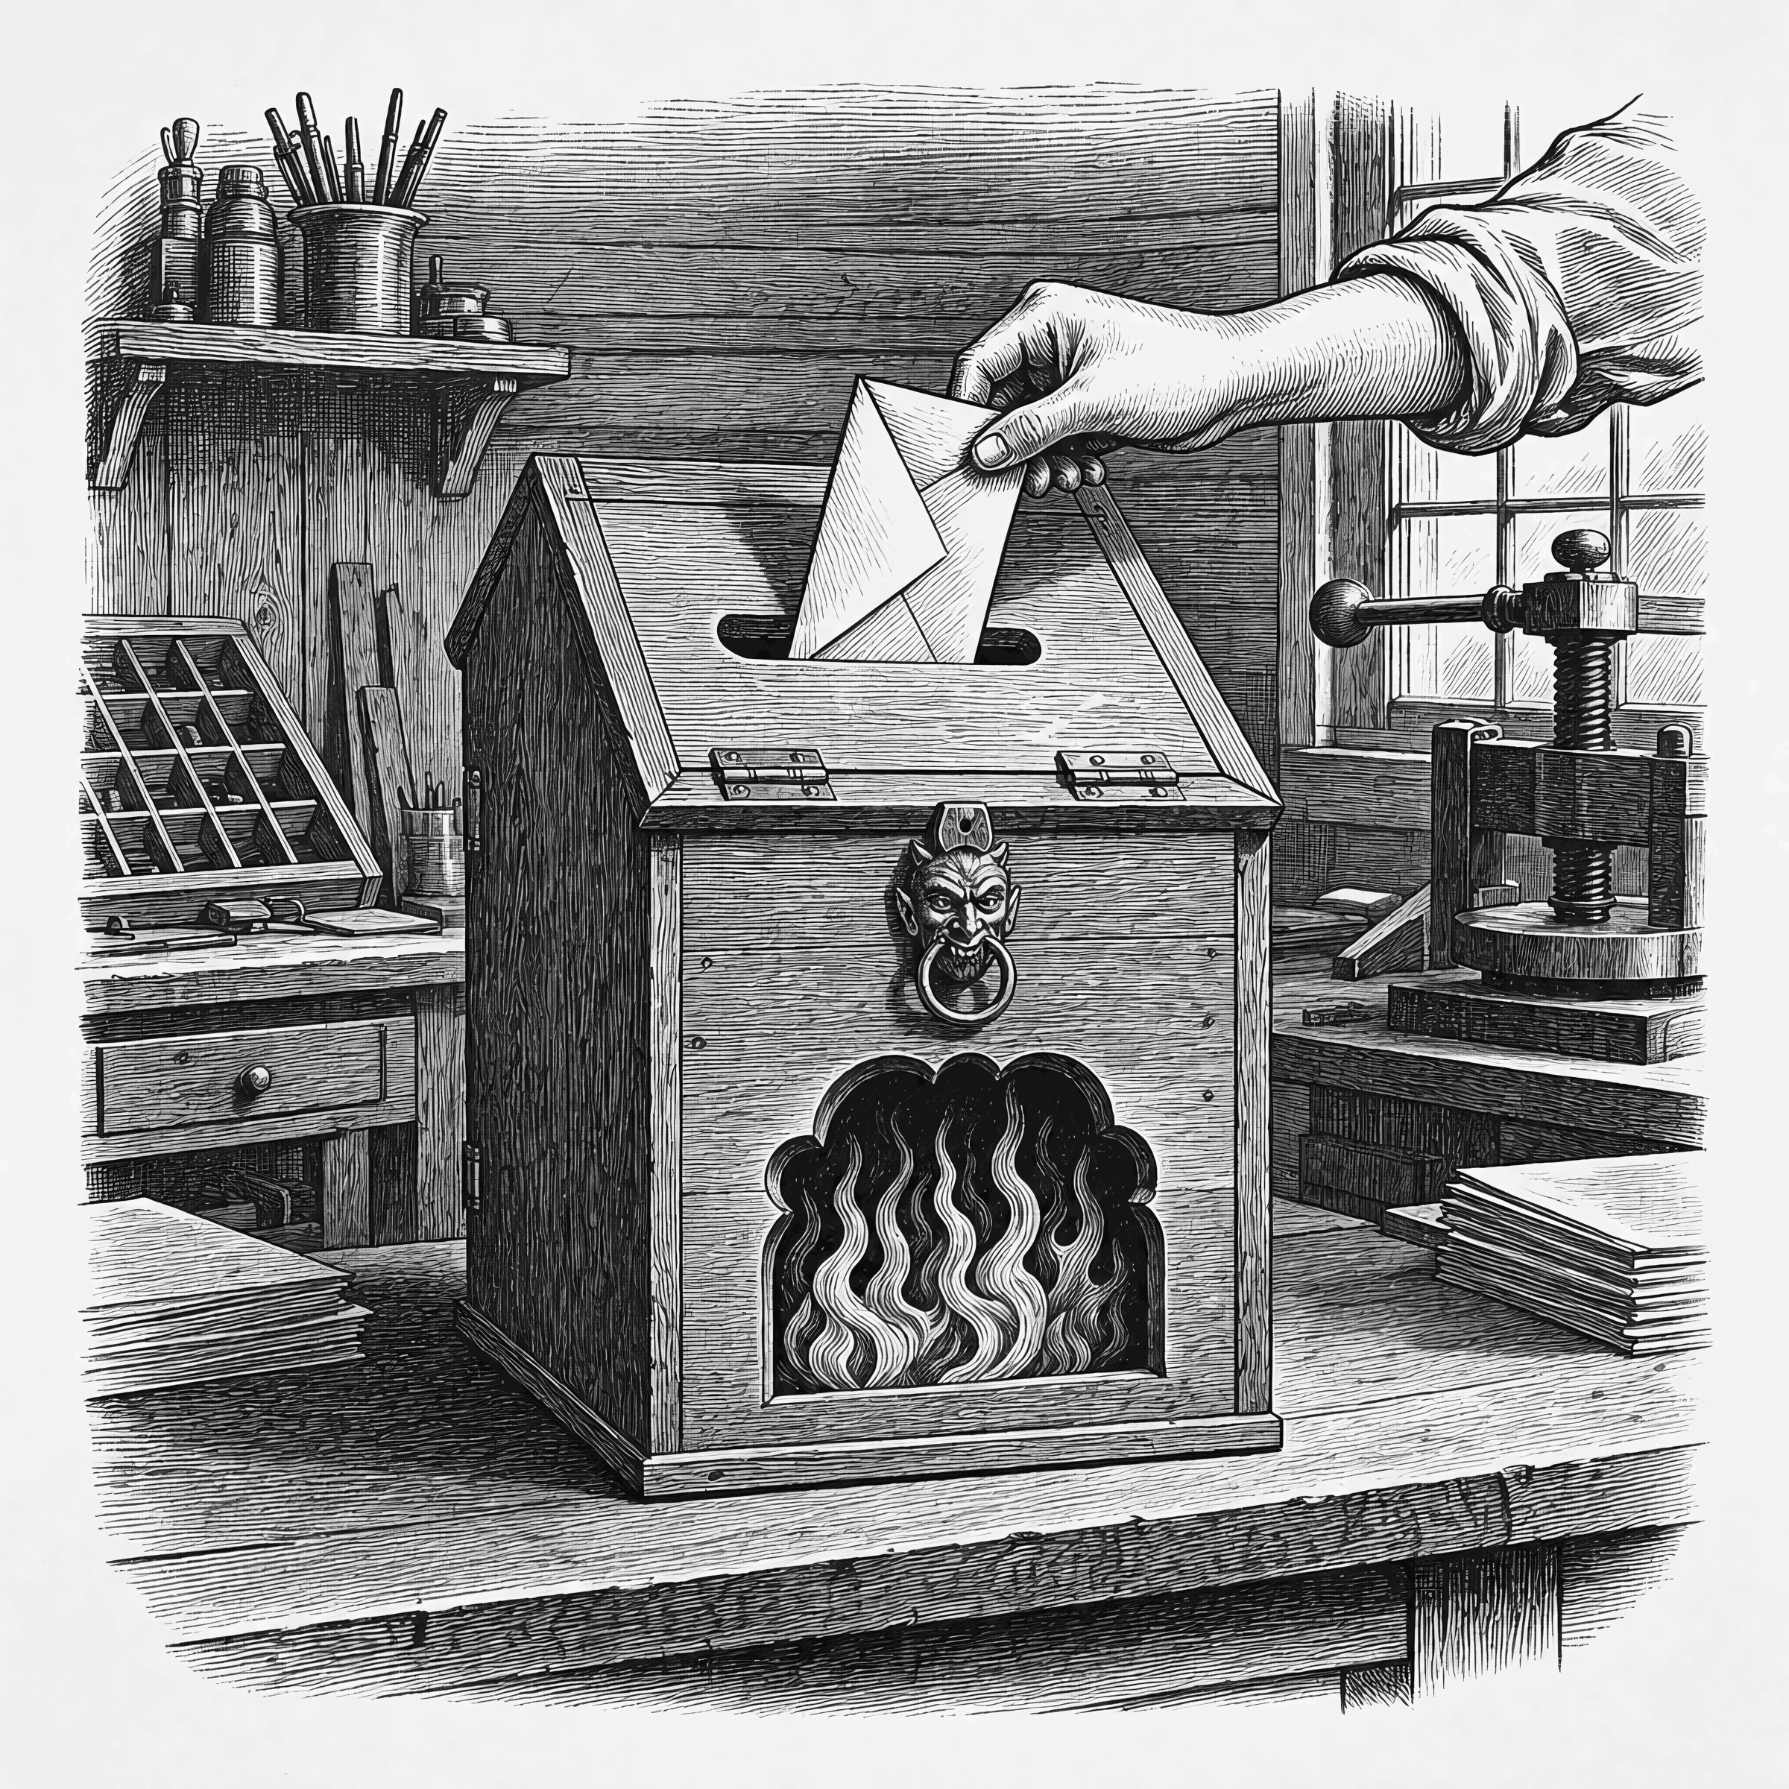
The hell box, kept where the whole shop can see it. The bent letter goes in so that it can never wander back.
In the corner of the old composing room stood a wooden box, and the box had a name. Broken type went into it: letters with cracked shoulders, battered faces, sorts worn so round they printed grey. When the compositor’s fingers caught a bad letter, he did not lay it on the bank to deal with later. He dropped it in the hell box. When it filled, hauling it off to the foundry was the sort of chore that fell to the devil, and the metal came back cast fresh. Nothing ever climbed out of the hell box and back into the case.
That was the whole design. A worn letter is dangerous because it is almost good. In the hand it feels like its neighbors. Under the press it prints a smudge, and it prints that smudge in every copy of every form it ever joins, and nobody notices until the sheets are folded. So the shop protected the case instead of the page: the compositor cannot inspect each sort as he sets, and at speed he trusts the case.
My shop keeps a hell box too. It holds pages instead of metal, and I keep them on purpose, because I use the box backwards.
In it are known-bad pages. A page with the forbidden long dash sitting in the middle of an otherwise decent sentence. A page whose headings carry hand-typed numbers. A page written in the banned vocabulary, every word the house has sworn off packed into one smug paragraph. Any of these would break the shop’s laws if it reached the press.
The proof-readers in this shop are machines, and a machine proof-reader has a failure mode metal never had: it can approve everything, forever, and look diligent doing it. A pattern with one character wrong matches nothing at all. A script that finds no files to inspect exits clean and reports victory. The devil, asked to make a slow check faster, will sometimes make it faster by teaching it to see less, and the run still ends in a green word. Until you have watched a check fail, you do not know that it can. It might be a proof-reader. It might be a rubber stamp with good posture.
So on every run, before a single real page goes under the glass, each proof-reader is fed the bad pages and must reject them. The old pressman packed and eased the impression until the first sheet printed true; he called that work makeready, and this is the same work. The dash-hunter must find the dash on its specimen page and condemn it. The heading check must catch the hand-numbered heading. The vocabulary law must flag every banned word in the smug paragraph, and the run counts the flags against the known total. No exceptions for the trusted checks; those are the ones nobody has read in months. A proof-reader that blesses a bad page fails the whole run, exactly as if the bad page were real. Only then does it get an opinion about the day’s work.
The blank-page detector is the plainest case. It reads the finished book for pages that carry no ink where ink belongs. The machinery produces such pages silently: let one figure outgrow its space and the press ships blanks from there to the back cover without a word of complaint. Before the detector touches the book, it must reject a fixture page that is truly blank and pass a fixture that carries a single mark. Both halves, every time. The blank fixture proves it can still see nothing. The marked fixture proves it can still see something, because a detector can fail that way too, condemning every page and burying the one real alarm. Skip either half and you may be running a detector that went blind in one eye. That is worse than no detector. With none, somebody would still be turning pages by hand.
Prose gets a hell box for the same reason. Every shop has words it has quit: the puffed-up verb, the phrase that sounds like a committee clearing its throat. Quitting by resolution does not work. You swear off a word in January and it is back by March wearing a suffix. So the ban lives in the shop’s law, the law runs on every page, and the law is fed its specimen paragraph before it reads anything real.
None of this costs much. The specimen pages are a few lines each. Feeding them through adds seconds to a run that already takes minutes, and writing a fresh one is a few minutes’ work if you do it while the failure is still on the screen. In exchange, every check in the shop has been watched failing that same morning.
The box grows from the wild. When a bad page slips every proof and a reader catches it in the finished work, the repair has two parts, and the order matters. First, cut a specimen of the failure and drop it in the box the same day. Not the same week. Today the failure is exact, the very dash, the very heading, trimmed to the smallest page that still fails. By tomorrow it is a paraphrase, and a proof-reader built against a paraphrase catches the paraphrase and misses the original. Then run the proofs. They stay green; this is the fault they could not see. Fix the proof-reader until the specimen is condemned. Only then fix the page.
A failure that never enters the box will be found again, later, by a reader.
The old hell box emptied toward the melting pot, and a full one meant the type was wearing out. Mine never empties, and I have stopped reading its size as shame. It holds every way a page has ever lied, kept where it cannot lie in earnest again, shown to every proof-reader on every run. The compositor trusted his case because broken letters could not come back. I trust my proofs because broken pages never left.
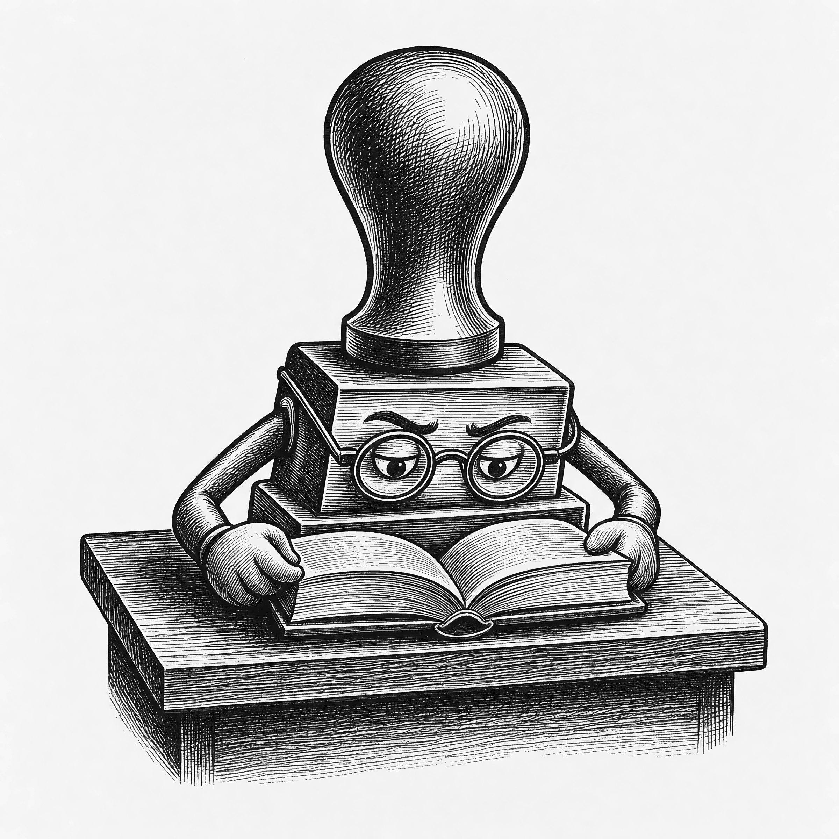
A rubber stamp with good posture, hard at its reading.

5 Proofs
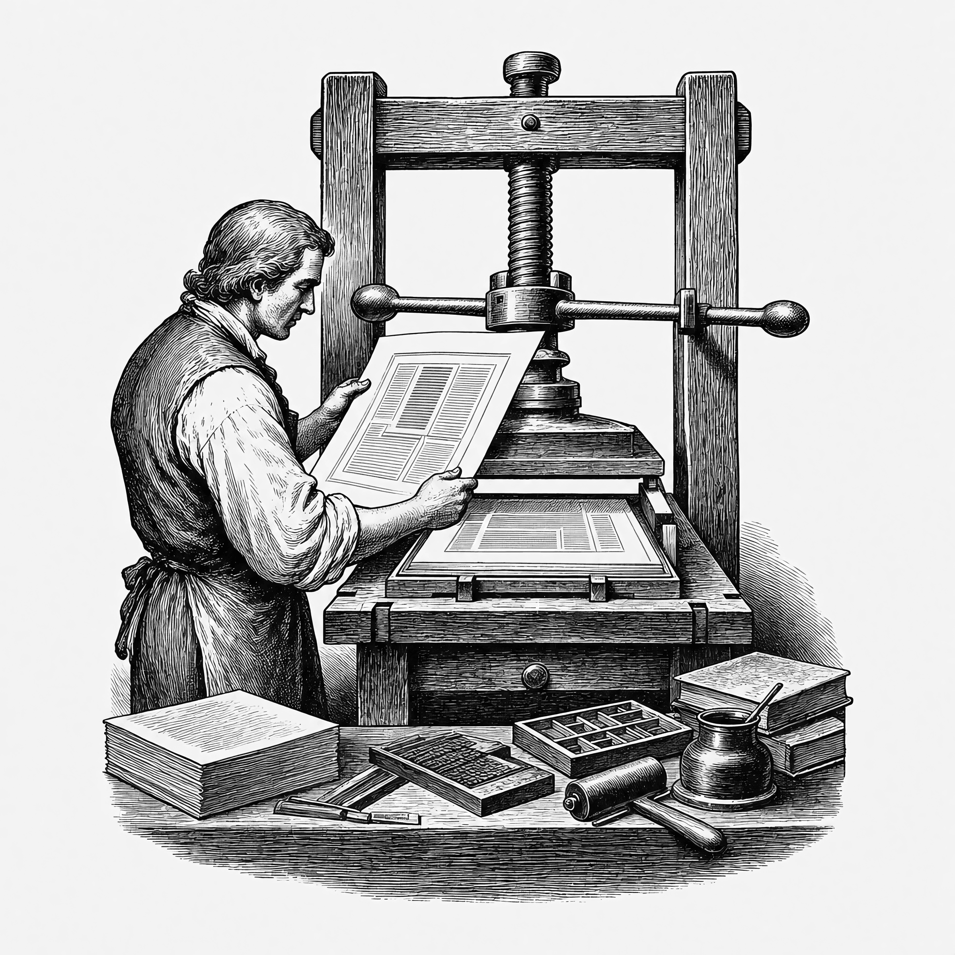
The press proof. The placard states the entire method.
The old shop proved its work twice, and never by asking the man who set it. First came the galley proof, a rough pull marked against copy in the reading closet. Then, after imposition and makeready, the pressman pulled a sheet at the press itself: the actual sheet, on the job’s own paper and ink, from the press that would run it. The master passed that sheet before he let the run begin.
He studied the sheet, not the manuscript, and not the compositor’s account of his own care. Intention leaves no mark on paper; only the press does.
Our shop keeps the custom. The devil sets the pages now. He is quick and tireless, and when he finishes he reports the work done. Sometimes it is. The evidence is the file on the disk, and the file does not care what anyone intended. So after every change we pull a press proof, and the proof puts questions to the file that the devil cannot answer for it. When the product is software, the press proof is the artifact a customer receives: the release installed fresh and run, the pages loaded as a stranger would load them, not the log that says the build completed.

5.1 What the proof asks
We still pull galley proofs, in their way: the prose gets read, the style gets checked line by line, the claims get held against their sources. But a galley proof only proves the words. The press proof proves the object, and it runs after every change, no matter how small the change looked. Small edits have wrecked whole runs.
Count the pages. The book has a length, and the proof knows it within a narrow band. A run forty pages short has dropped a chapter; a run forty pages long has set one twice. The count catches either before a reader can.
Measure the trim. The leaf has one size, and every page must hold it. A stray setting can shrink the block or swell the margins without a word of complaint, so the proof measures the first page, the last, and a handful between.
Confirm the faces are embedded. A book that borrows its type from whatever machine opens it will look different on every machine. The proof looks inside the file and confirms that every face travels with it.
Find the sentinel lines. The shop keeps a few ordinary sentences from the prose, sentences that survive only a real run: one from the opening chapter, one from the last, one from deep in the middle. If a sentinel is missing, the press set something other than the book, however handsome the result. Take the sentinels from the prose itself, never from the front matter; a title page survives almost any disaster.
Render every page and look at it, every one, not a sample. Each must carry ink, because a blank leaf where prose belongs still counts as a page, and no count will catch it. Nothing may touch the edge, because the knife takes half of any line that kisses the trim.
Follow every link in the plate list. Each entry claims a page; the proof turns to that page and confirms an image truly stands there.
None of this is subtle work, just counting, measuring, and looking, the oldest work in the shop. The proof never asks whether the book is good, only whether the file in front of you is the book.

5.2 Never proof yesterday’s sheets
The proof pulls a fresh sheet, every time. A proof examines whatever sheet you hand it, and it will bless a stale one as happily as a fresh one. Change a line, then proof last night’s run, and the proof comes back clean; you have checked yesterday’s work and learned nothing about today’s. The sheet it read predates the change.
So in this shop the pull and the proof are one motion. The press runs first, then the questions are put to what it just produced. Do not trust anyone, yourself least of all, to remember the order at the end of a long day. Build the rebuild into the proof itself, so that skipping it takes more effort than doing it. A proof that can be pointed at old sheets is not a proof. It is a ceremony.

5.3 The run that lied
One book taught this shop to render every page. A plate came in a fraction of an inch taller than the text block. The press took it without a warning, reported success, and shipped blank leaves where the rest of the book belonged, run after run, from that plate onward. Nothing in the machinery ever objected.
A person caught it, by looking: turning the rendered pages one at a time until white space appeared where prose should have been, then paging on through leaf after leaf of nothing. The fix took minutes; crop the plate a hair shorter than the block and the book came back whole. The habit of turning every page went into the proof that same day.
The press was not unusually faulty. Every press has failures nobody has met yet. A success report measures the press’s satisfaction with itself, and this press was entirely satisfied with a blank page. You have to look.

5.4 The copy on the shelf
One distinction outlasts publication day. The copy on the bench, the one the press just produced and the proofs just blessed, is not the copy a stranger will be handed. Between the run and the shelf come the gathering, the wrapping, the carting, the shelving, and any of them can hand the customer something other than what the press produced. None will mention it, because none knows. Proofing the bench copy proves the press. Proving the copy on the shelf belongs to release day, where this manual takes it up.

6 Imposition
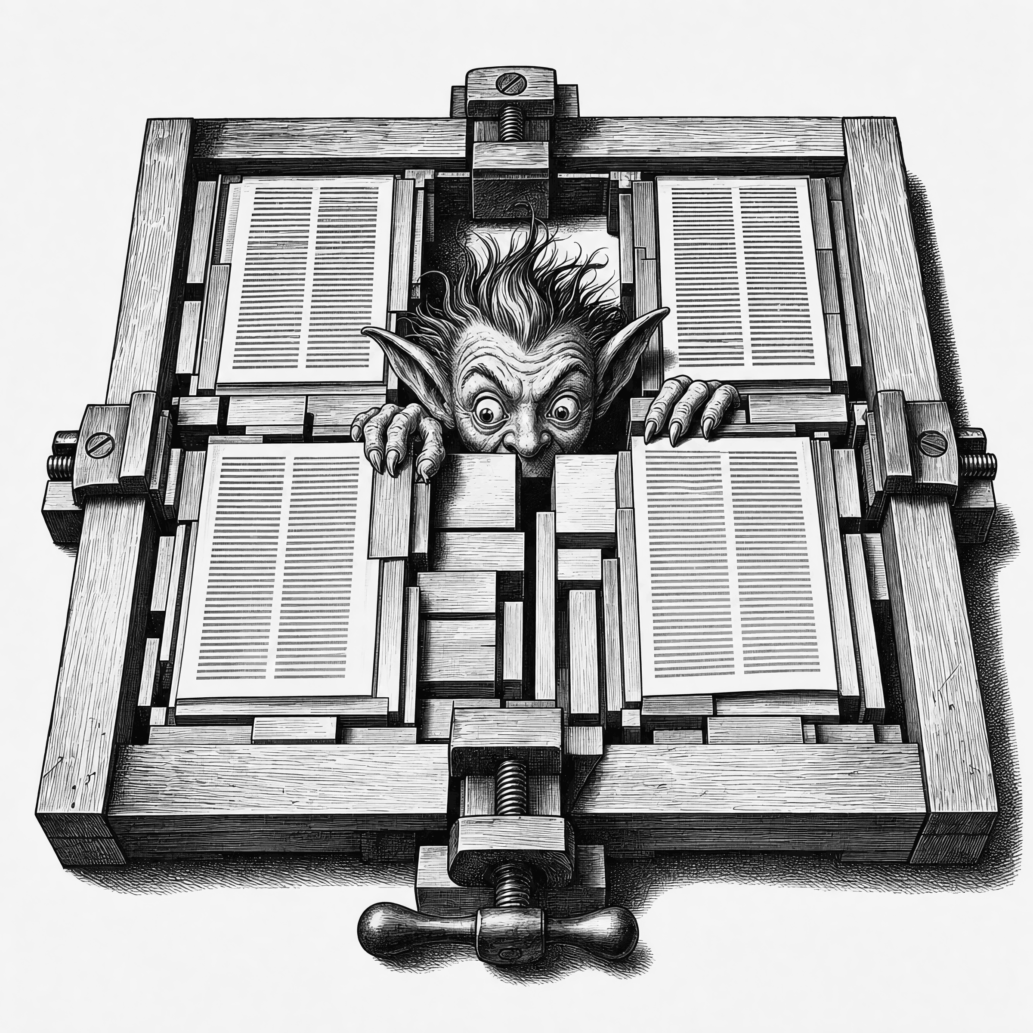
The forme, imposed and nearly locked. One page is missing, and something has come up through the gap to see about it.
Imposition is the step where the compositor stops thinking in pages and starts thinking in sheets. Eight pages of set type go onto the imposing stone for one side of an octavo sheet, and the arrangement looks like a mistake: the first page beside the last, half of them upside down, nothing in reading order. The scheme is correct when the printed sheet, folded in half three times, yields a gathering of sixteen pages that read in sequence with every head at the top. The compositor locks the pages in the chase with furniture and quoins, lifts the forme, and sends it to press.
The trouble with imposition is that its errors are invisible where they are made. Every page on the stone can be perfect, the proofs clean, the ink even. The error lives in the relationships between pages, and those appear only after the sheet is printed, folded, gathered, sewn, and trimmed. A careful shop catches a transposed page when it reads the imposition off the proof; a careless one meets it in the bindery, with the edition already through the press.
We impose too. The devil sets clean pages all day, and each one proofs fine alone. What folds them into a book is machinery: the layout engine that places the plates, the passes of the run that build the front matter and the lists, the link tables that carry a reader from a reference to its target. Errors made there have the old property. Nothing complains at the stone. The book comes out whole with the fault bound in.
Three wounds from this shop.
A new machine came in with one face missing, the one used for keyboard text. Nothing stood in for it. Every character set in that face simply vanished from the printed page, with no warning and no substitute. A compositor who ran a box empty at least knew he had, and stopped, or set a turned letter as a placeholder that printed as a black mark until the right sort came. This press kept printing, and the run finished green. The only witness was the proof: lines with holes where words should have stood.
The list of plates was built by the run itself, from notes the machinery takes as it places each figure. The notes from one pass feed the list on the next, so the list needs several passes to converge. Run once, the build reported success and the list printed empty, a heading with nothing under it. Every individual page was correct. Only a reader turning to the front matter would ever know.
The links in that list anchored at the captions rather than at the plates. A caption sits below its figure, and when the figure fills a page, the caption falls at the top of the next one. So every link delivered the reader one page past the picture. Follow the entry for the fourth plate and you land on the blank verso after it. All the links worked. Every one was wrong by one page.
None of the three raised an error. The machinery did what it was told, at full competence, and the defect belonged to the finished object. You found it by opening the bound proof and looking.
The practice: each wound becomes a rule, and the rule is built into the frame where the work happens, not written in a note.
So the missing face became a law of the rebuild. The full fount list is written into the instructions that raise a new machine, and the proof hunts one sentinel character from each face in the finished pages. A note in the shop manual would not have done it. The devil raising a press at midnight has not read the manual, and neither have you, at midnight.
The empty list became a pass count the run performs. The run repeats until the lists converge, and it will not hand over a book from a single pass. Nobody remembers to run it again; the run remembers.
The wandering links became a step in the proofing. After every impression, the proof follows each entry in the list of plates and checks it against the page that really holds the picture. The check takes seconds. When a link overshoots, the run fails loudly and the shop stops.
The second practice follows from the first: the scheme is pinned. A book imposed today must impose identically tomorrow, same faces, same measures, same folded result from the same set pages. If the margins creep because some component updated under you, or a face substitutes silently on a new machine, the book has changed and nobody chose the change. Drift in imposition shows up bound. In software you know it by its plain names: the toolchain nobody pinned, the dependency that updates itself overnight, the build that differs between two machines.
So pin everything the fold depends on. The faces travel with the shop. The tools are named by version. The scheme lives in one place, and the run reads it rather than remembering it. When you want a wider measure or a new face, you change the pinned scheme deliberately, and the change is a new edition, dated and recorded, its proofs opened and read before it ships. In the old shop a forme once locked stayed locked, and standing type could reprint a title years later, line for line. Your shop can make the same promise.
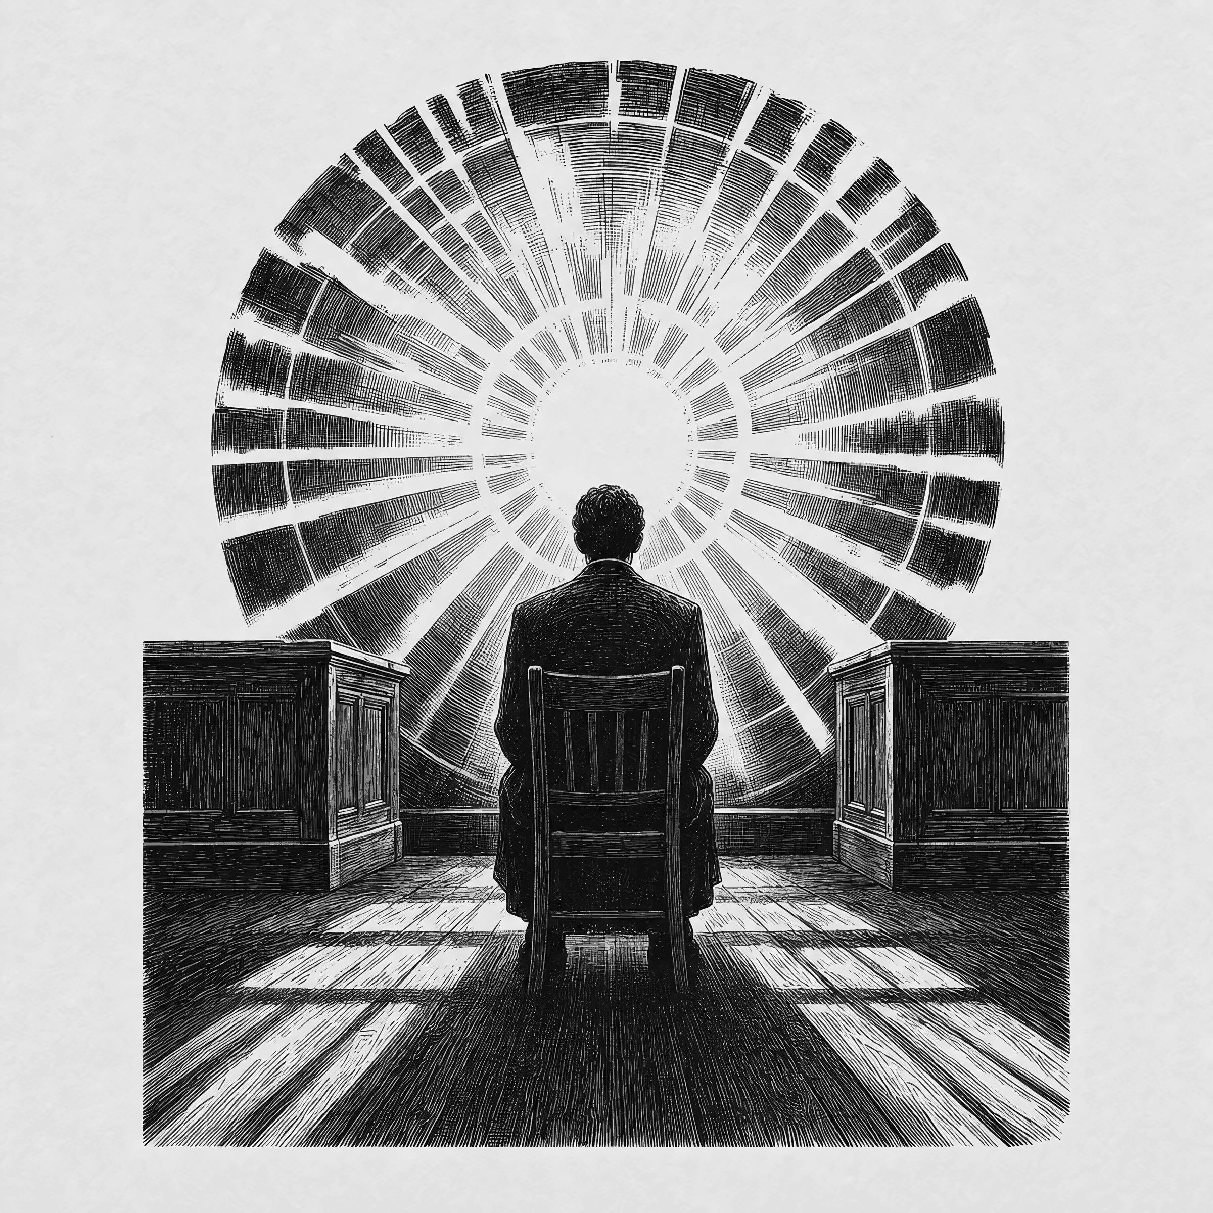
The only witness. Light through the proof, where the words should have stood.

7 Plates

The engraver cuts the words exactly as written, reading none of them.
The engraver never met the author. A parcel came to his bench: a drawing, or a page of close description, and he cut what he was given into the endgrain of a boxwood block, line by line, until the picture stood in relief. If the scene needed lettering, a shop sign, a name on a hull, a headline on a discarded newspaper, he cut the letters in mirror image, exactly as written; if the brief had a misspelling, the block carried it. Publishers learned to write every word out fair, because a man cutting reversed letters at speed does not pause to wonder about spelling. When the book was bound, a list of plates stood in the front matter, each picture named with its page, so a buyer at the stall could riffle the copy and see that nothing promised had been left behind at the bindery.
The machine that cuts our blocks has never held a graver either, and every part of that old discipline transfers whole.

7.1 Brief the object
The devil will draw anything you can describe. A style label is not a description. Ask for “a Victorian engraving” and you get the average of every engraving ever scanned: correct hatching, dead scene. Describe the object instead. A hand press with the bed racked out. A devil no taller than the forme he staggers under. Morning light from one high window, falling left to right. Spoiled sheets on the floor and one clean proof pinned to the wall. Name the tools by their right names and say what each figure is doing with its hands. Everything you specify appears. Everything you leave open gets filled with the most probable furniture, which is how a composing stick becomes a vague tray and a chase becomes a picture frame. Write the brief as a bill of materials for the picture.

7.2 Every word on the plate, verbatim
Name every word that must appear on the plate, in quotes, letter for letter. Text left implicit will be misspelled or invented, and invented is worse: the sign over the door will say something almost like what you meant, in letterforms too handsome to doubt. The old engraver cut mirrored words in languages he could not read; he reproduced the shapes without reading them. The machine does the same until the shapes run out, and then it improvises. So the brief says: the sign reads “SORTS BOUGHT & SOLD”, exactly. The ledger spine reads “1893”, exactly. Then one clause more: no other lettering anywhere. Leave that clause out and the machine will letter every surface it can reach, crate lids, window glass, the folded newspaper on the floor, all of it earnest gibberish.

7.3 One idea per plate
A picture arguing two points argues neither. If the plate is meant to show the folly of trusting an unread proof, it does not also get to show the virtue of good imposition. Cut two blocks. Each plate carries one claim, the caption states the claim, and everything in the frame either serves it or comes out of the brief. A rich scene tempts you the way a long sentence does. The test is the one you use on a paragraph: say what the plate is about in one sentence. If the sentence has an “and” in the middle, that is two plates.

7.4 Earnest hand, absurd subject
The drawing stays dead earnest. Whatever is funny in these plates is funny because a devil is gravely doing something ridiculous, rendered with the sobriety of an alderman’s portrait. Ask the machine for a funny picture and you get mugging: bulged eyes, sweat drops, a scene that elbows you in the ribs. Ask it for a solemn technical illustration of an absurd subject and the plate lands. The joke lives in what is depicted. The engraver of the old shop cut a satirical block with the same patient burin he used for a duchess.

7.5 Formats follow the grain
Engraving texture is thousands of near-parallel lines broken by crosshatch, closer to photographic grain than to flat line art. The thrifty lossless formats built for flat tone choke on it: every line is an edge, nothing repeats, and the files swell without one visible line gained. Photographic compression was tuned for exactly this kind of continuous texture and handles it without complaint. So the shop takes the pragmatic format, sets the quality dial at 88, checks the result under a loupe, and stops arguing. This offends people who want the archival format on principle. The principle is sound and the paper does not care. The test is the same as everywhere else in the shop: look at the plate at the size it prints. Either you can point to a fault or there is no fault.

7.6 The list keeps itself
The list of plates in the front matter is assembled, never maintained. The build reads every chapter, collects every plate the text calls for, and walks to the drawer to check. A plate referenced but missing stops the run before a sheet is wasted, the way a missing block stopped the old pressman before he inked a forme with a hole in it. A plate sitting in the drawer that no chapter calls for stops the run too. Removing a picture from a book means changing the text and clearing the drawer, and a check that watches only the text will bless a drawer full of orphans until one of them wanders back into print.
Captions are written for the list, where they stand alone, far from their chapters, so each one must name its picture outright: “The devil pulls his first proof,” never “The result of the process described above.” Read the assembled list by itself before a release. If every line makes sense with the book shut, the captions are done.
When the product is software, the plates are its generated assets, the diagrams, icons, and sample pages the build produces, and the list of plates is the manifest they are verified against: everything referenced present, everything present referenced. The buyer riffling at the stall is still with us either way. The list is the work’s promise of what it contains, and the build keeps that promise, because your memory will not.

8 The wayzgoose
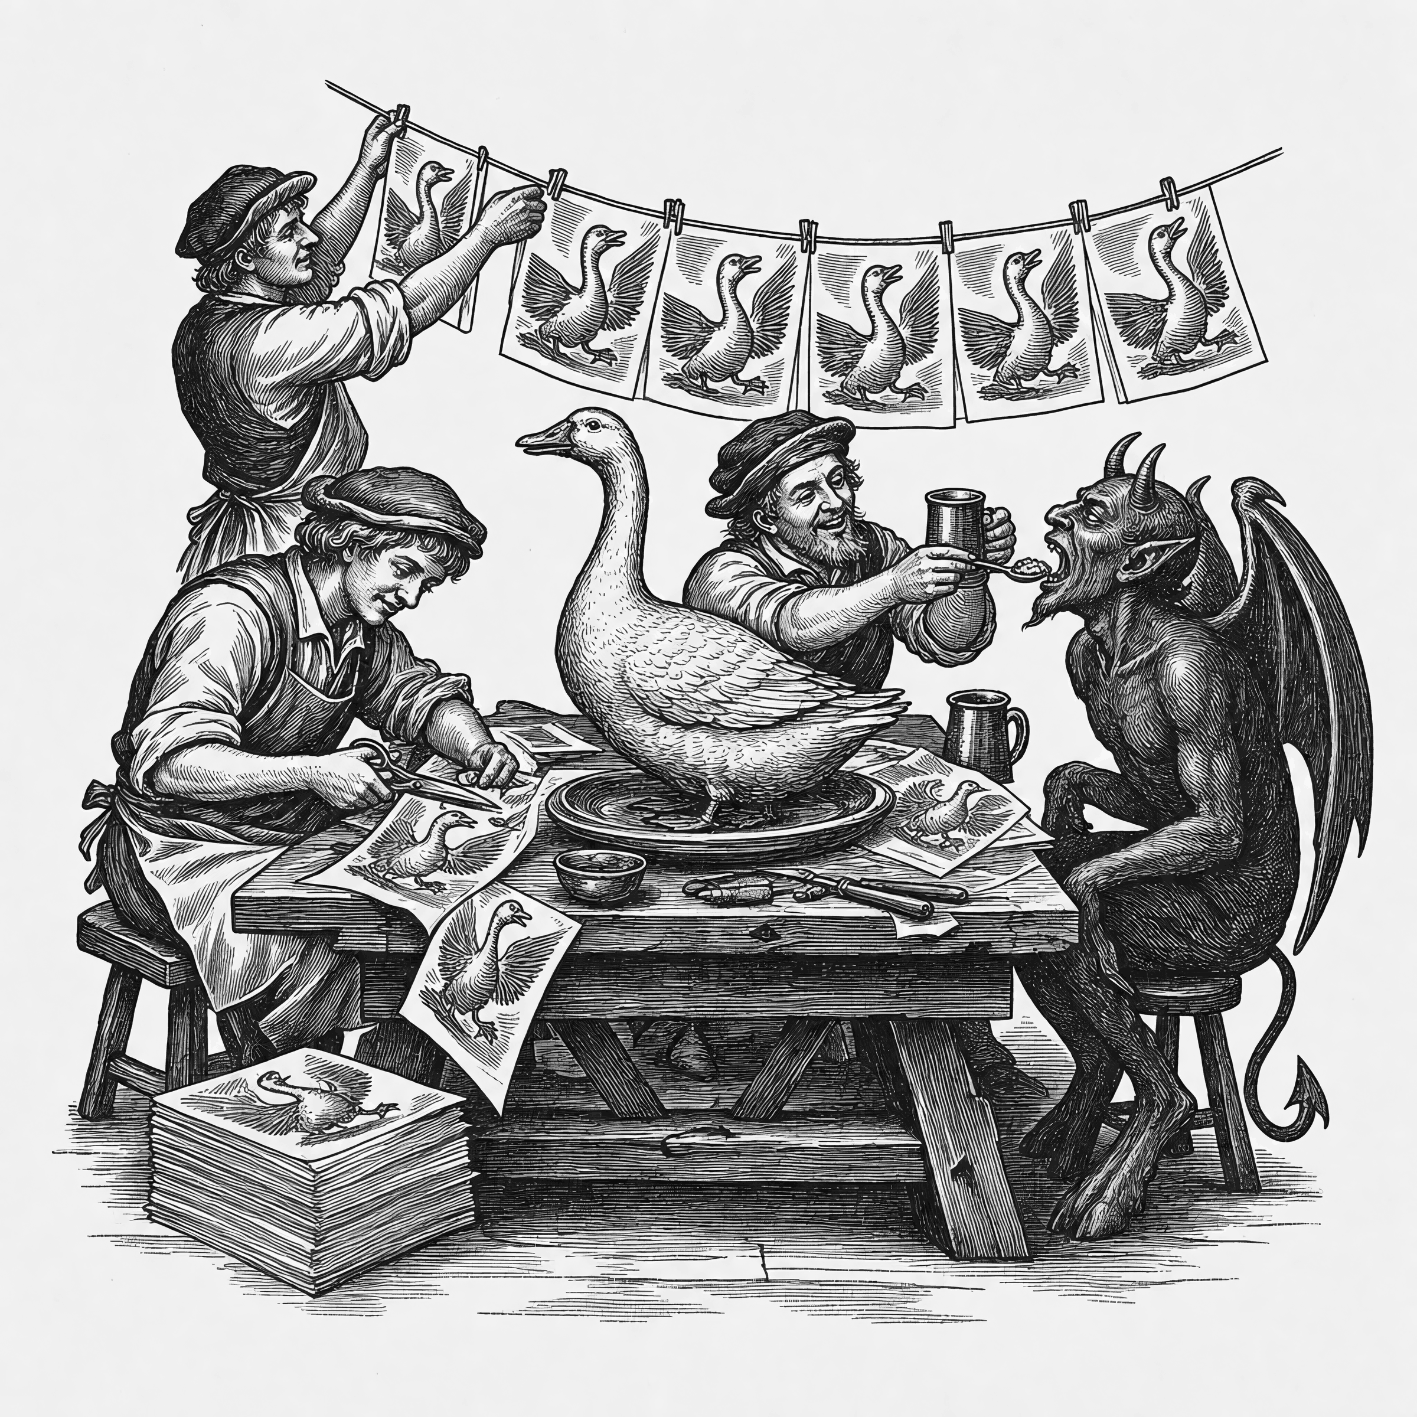
The wayzgoose. Proof sheets for bunting, a goose for the table, and the devil fed at last.
The old shops kept one feast a year. Late in August, around Bartholomew-tide, when the evenings began to shorten and the compositors would soon be setting type by candlelight, the master gave his men a dinner. They called it the wayzgoose. The manuals that record the custom cannot settle where the word came from, but they agree on the shape of the thing: the work was turning with the season, the turn deserved marking, and the master paid. The devil ate at the same table as the journeymen. Then the whole shop went back to work in the dark half of the year.
The feast came when the season came, around Bartholomew-tide in late August, the point when the shop began working by candlelight again. Later shops let it drift toward high summer, but it stayed a fixture on the calendar, not a thing summoned to flatter a visitor or force a mood.
The modern shop keeps the feast too. It is called release day, and it differs from the wayzgoose in one way: the wayzgoose was scheduled, and release day is gated. A season turns on the calendar whether the sheets are clean or not. An edition leaves the shop when the gates open, and the gates do not open because a date arrived or because somebody promised a demo in a meeting.
There are three gates. The machinery holds them, because on feast day you will want to let one slide.
The run leaves only from the main line. Whatever sits on your bench, however finished it looks, it is not the edition. The main line is the copy the whole shop can read, the copy every proof has run against, with no private corrections still in someone’s pocket. Land the work there first.
The run leaves only with the ledger entry already written. The notice comes out of the ledger; nobody composes it on feast day. The trap is in the ordering. Roll the accumulated notes into a dated section that matches the tag before you tag. Tag first and the extractor finds nothing, and an empty notice stops the run cold. If you cannot write down what changed in this edition, the edition is not done.
And the run leaves only after every sheet has passed proof. A build can complete and still produce a book that will not open, so exit codes are not enough: every format built, every check green, the finished copies opened and inspected as objects.
When the gates are satisfied, one tag starts the machinery, and from there it runs alone: it builds every format, proves each one, publishes the edition, and attaches the notice it pulled from the ledger. Your hands are off the press.
When a gate is not satisfied, the machinery refuses. A shop tagged a release candidate with the season’s notes still sitting under the unreleased heading of the ledger. The extractor went looking for a section matching the tag, found none, produced an empty notice, and the run stopped before a single copy left the building. Nothing had shipped, so nothing needed rolling back. The repair was one commit, rolling the notes into a dated section, and a second tag. The grumbling outlasted the repair.
The refusal was right. A system that will say no to you while you are reaching for the glass is the only kind worth building, and this one did: an edition would have gone into the world with no account of what it was; no reader could have learned from the shop what changed or why. The machinery declined to publish an unlabeled book.
Then the run goes green, and you will want to take its word. Do not. Go where a stranger would go. Follow the public path, not your bookmarks and not the build directory. Download the published copy from the place a reader will find it, open it, and read a page from the middle. Look at the type, follow a cross-reference, and check that the plates landed where the list says they did. The copy in a stranger’s hands is the fact; everything before it was rehearsal. The whole inspection takes ten minutes.
Then, and only then, the feast. Scale it to the shop. In a shop of one or three, the wayzgoose may be a good dinner, a closed laptop, an evening that does not smell of the press. Take it seriously anyway. Skip enough feasts and shipping starts to feel like any other Tuesday, and then it starts to mean nothing. The devil worked the whole season beside you and does not eat. The feast is yours.
One duty remains, and it belongs to the same evening, while everything is fresh. Open the ledger and write the honest paragraph: what went wrong in this edition’s run. Not the triumphs; the notice already holds those. The gate that refused you and why. The check that passed when it should not have. Any step you did by hand, because the machinery should have done it and the ledger should say so. Write the symptoms exactly, with the numbers still sharp. By morning they soften into anecdote. By next month they are gone.
The next edition inherits everything this one records, and only what it records. The unreleased section that starts filling tomorrow sits directly under this paragraph. Whoever opens the ledger to begin the next season’s work, you or the devil, reads it first.
Then back to work in the dark half of the year.
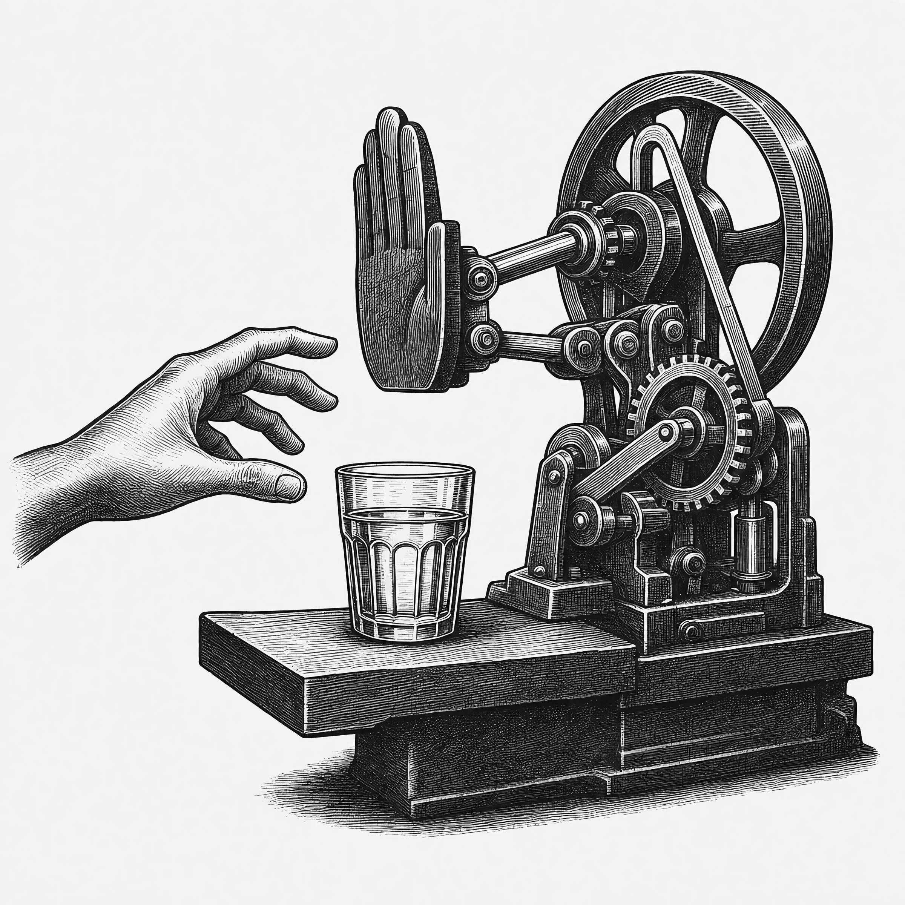
The empty notice. The machinery says no while the hand is reaching for the glass.

9 The colophon
The earliest printed books had no title page. To learn who made one, you read to the last leaf, where the printer set a few lines of his own: his name, his city, the year, and often a word of thanks that the labor was over. This was the colophon, and for a generation it was the only place a book admitted to having been made at all. When the title page arrived and carried the announcements to the front, the colophon kept the craftsman’s share: the name of the type, the paper, the size of the edition, sometimes the names of the people who sweated over the formes.
Your software deserves the same last leaf. An about box, a footer, a block at the end of the release notes: who built this, where, with what, in what year. Four lines, ten minutes of writing. Say plainly that a devil set the type. The finest presses named their compositors in the colophon, back when the compositor was flesh, and the habit is worth reviving now that the compositor is not. The certification never came from the hand that set the type anyway. It came from the shop that pulled the proofs and signed the run.
The colophon names the maker, the town, the materials, the year. It does not print the shop’s ledger, its correspondence, or its list of customers, and no reader ever called that silence shifty. The buyer is owed the truth about the object in hand. The interior of the shop is nobody’s business. So publish the toolchain, the version, the record of what changed and when. Keep the transcripts of your sessions with the devil, and the names of the people you print for.
There is a difference between withholding and hiding. A rights page that prints “registration number pending” tells the truth twice: about the paperwork, and about the shop’s habit of saying so. Dropping the line is quieter and slightly false, because a reader who looks for it will assume an answer you never gave. The same holds for software. “Restores are tested by hand each month; automation is planned” beats a page of borrowed badges. Mark the pending. An honest blank is a promise with a date on it.
The old printers’ marks worked the same way. The dolphin wound around the anchor, the orb under the double cross: small devices cut into the book to certify its origin, in an age when a good edition drew counterfeits within the season. The mark claimed one thing, that this shop and no other made this. It said nothing about the shop being large, or modern, or the finest in the city. Sign your run in that spirit, smallness included. A printer who ran off two hundred copies said so in the colophon, without apology; the number was a fact about the book, and facts about the book belong there. Write “built and kept by two people and a devil” the same way. The customer who needs a thousand-person vendor was never yours. The one who needs the work done well would rather know exactly who stands behind it, and how few doors there are to knock on.
The rights notice deserves the same honesty, and here the irreverent tradition is the truthful one. One press sets, under its device, a notice to the effect that anyone may reprint the work who does not pretend to have set it themselves. Every word of it is true, because it claims exactly the protection the press intends to enforce, which is nearly none. Set beside it the usual boilerplate: all rights reserved, in the sternest type, from a shop that has no lawyer and never will. Ask what you would actually do if someone copied the work. If the answer is “ask for credit and get on with the next run”, print that. A reader can tell which kind of shop wrote each notice, and trusts the honest one with the rest of the page.
The colophon also fixes the work in time, and this matters more now than it did. “In the year of our Lord” told a later reader what tools and knowledge the maker could have had. Your year does the same. Say the system was built in a particular year, with the devil of that year, and a reader can judge it against what was possible then. You can reread it without flinching, too. Nobody faults a hand press for lacking rollers that had not been invented.
And with that line set, this manual is done. The shop is ready when the question “is it done” has standing witnesses. The proofs were pulled and read by someone hunting for trouble. The count was checked against the order. The devil’s work passed under eyes that owed it nothing and had refused it before. Every one of those witnesses could have said no. A witness who cannot refuse is an ornament. When the last of them has nodded, set the colophon: name, place, tools, year. Pull the run. Lower the lamps on your way out. The press will want making ready again in the morning.

The device goes on last: this shop and no other, smallness included.

Appendix A: the scar ledger
In the old shops the lessons lived in the foreman. He knew which chase sprung its quoins, which press ran hot after dinner, which apprentice could not be trusted with the good ink. When he left, the shop bought every lesson again at full price. This ledger exists so ours are bought once. A scar is a lesson with a receipt: the exact symptom, the work it cost, and the law we cut into the shop rules the same week. It lives where the next edition must trip over it, and the devil reads it before every job. Nothing goes in on suspicion. Every entry below was paid for first.
A plate taller than the page ships blank pages forever. One book carried an engraving taller than the 7.5 inch text block, and the press raised no error. Blank page after blank page went out until someone opened the proof and found white where the chapter should be. The law: no plate exceeds 7.1 inches, and every proof gets opened to the plates before anything else.
A list built across passes prints empty on one. The list of plates gathers its entries over several runs. Run once and the heading stands over white space, and the build still reports success. It looks like a page reserved on purpose. The law: build through the machinery that runs until the lists converge, and treat a lone pass as no build at all.
Links anchor at the caption, not the picture. In one book every entry in the list of plates dropped the reader a caption’s height past the plate it promised, which on a short page meant the next page entirely. Every link resolved, so every check passed. The law: after touching any link, follow it to the page that actually holds the target.
A minimal fount installation drops glyphs without a sound. One shop’s stripped-down installation lacked the face used for keyboard text. Every character set in that face vanished from the printed page, with no warning and no substitute. The law: write the full fount list out wherever the shop gets rebuilt, because “recommended” will not pull in what the page depends on.
Proofing yesterday’s sheets blesses yesterday’s work. A verification run against sheets already sitting in the delivery room passes no matter what you broke this morning; you have proofread the past. One shop shipped a known defect with a fresh green stamp on it. The law: rebuild and verify in one motion. A bare check of standing sheets proves nothing about today.
A pipeline answers the last question asked, not the one you meant. One check’s verdict passed through a search command on its way out, and the search’s exit stood in for the check’s. The search kept finding its pattern, so the pipeline kept reporting success, and failures rode out the door as passes until someone read the raw log. The law: take the signal from the tool that did the judging, and let nothing downstream speak over it.
The first run of new machinery looks exactly like a hang. A fresh press stalls for several minutes at full effort while it catalogues its founts, and gives no sign of life while it does. One shop killed the run twice, rebuilt twice, and lost a morning to a machine that was trying to finish. The law: learn what a first run looks like before you interrupt one, and write the warmup into the instructions for the next fresh machine.
An index term that matches nothing sits dead for editions. A curated term drifted out of the prose during revision and kept its line in the index, pointing at nothing. No reader complained. The law: a term with zero hits fails the build, the same as a broken page number would.
Attributes ship as literal marks in the plainest edition. In the edition with no italic and no bold, emphasis went out as the marks that had asked for it: asterisks framing the words they were meant to dress. The richer editions all proofed clean, so nobody looked at the poor one. The law: proof the plainest edition first. It has the least machinery standing between a mistake and the reader.
Delivering to a new shop does not count as a change. The machinery that watches for changes and re-hangs the public sheet never fired on the first delivery; before that delivery there was nothing to have changed from. The sheet hung blank for a day while every gauge inside the shop read green. The law: after the first delivery anywhere, walk around front and look at what the public sees.
New wounds go in the same day they close, while the receipt is still legible. A month later nobody remembers the exact symptom, and the entry that would have stopped the next repeat never gets written.

Appendix B: a glossary of the shop
The terms this manual leans on, each given its old meaning first and then the one it carries here.
Makeready. The hours spent packing, adjusting, and proofing a press before the run, so the ten-thousandth sheet would print as evenly as the first. In this shop: everything you build before the work begins in earnest; the checks, fixtures, and environment that make the first pull a fair test of the job.
Sorts. The individual pieces of type, one character to a piece; a compositor who ran short of a letter mid-job was out of sorts. In this shop: the small standard parts your build depends on. Out of sorts still means the job is stopped, or should have been, for want of something as small as a font.
The devil. The printer’s apprentice, named for the ink he wore and the mischief expected of him, trusted with real work under a journeyman’s eye. In this shop: the coding agent. It sets faster than any hand that ever lived. It is the apprentice all the same.
Titivillus. The demon medieval scribes blamed for the errors in their copying, said to gather every dropped word in a sack against the day of judgment. In this shop: the name for any defect blamed on the tools when nobody ran the check that would have caught it.
The hell box. The box under the frame where broken and battered type was thrown to await melting back into clean metal; nothing ever climbed out and back into the case. In this shop the box runs backwards: it is the kept collection of known-bad pages, fed to every proof-reader on every run. A reader that passes one of them is broken. Pages are added and not removed.
Galley proof. A rough proof pulled from type still standing in its long tray, read for errors before the pages were made up. In this shop: the diff, read while the work is still loose and a correction costs minutes instead of a rebuild.
Press proof. The sheet pulled on the actual press with the actual ink and paper, approved before the run was let go. In this shop: the built artifact itself, opened and read; a passing build is a promise, a press proof is evidence.
Foul case. A case with letters lying in the wrong boxes, so a careful compositor set errors with a clean conscience. In this shop: a corrupted environment or a stale instruction file, which lets the devil do careful work that is wrong.
Imposition. The arrangement of pages in the forme so that, once printed and folded, they fall into reading order. In this shop: the ordering of parts so the assembled whole comes out right, decided before the run and never patched by hand at the end.
The chapel. The self-governing body of journeymen in a printing house, with its own rules, its own fines, and a father to enforce them. In this shop: the written house rules that bind every hand, the devil included. They still apply on a bad morning.
The wayzgoose. The master’s annual feast for the whole shop, marking the turn of the season when work went on by candlelight, and the one day the master fed the shop. In this shop: the release. Before the feast, someone downloads one of the shipped files and opens it.
Colophon. The note at the end of a book naming the printer, the type, and the manner of its making. In this shop: the honest statement of how the work was produced, tools named, the devil among them, so the reader knows what manner of shop made it.
The plate. The engraved block that carried a book’s picture, cut by a craftsman who never met the author and reproduced the brief exactly, right or wrong, then named with its page in the front matter. In this shop: the commissioned illustration, briefed to the letter and verified against the list of plates the build assembles on every run.
The ledger. The book where every job, charge, and hour was entered as it happened, because the shop’s memory was worth money. In this shop: the version history, written as the work lands; an entry reconstructed a week later is fiction.

Appendix C: Index of subjects
Numbers are chapters and letters are appendices; both stay put across editions, which page numbers do not. The locations below are found in the text on every build, so the index cannot drift from the book.
bindery · 6, 7
candlelight · 8, B
chapel · 3, B
chase · 6, 7, A
colophon · 9, B
composing stick · 1, 7
compositor · Preface, 1, 2, 3, 4, 5, 6, 8, 9, B
copy · Preface, 1, 2, 3, 4, 5, 7, 8
engraving · 7, A
forme · Preface, 1, 3, 6, 7, B
foul case · 3, B
fount · 6, A
furniture · 2, 6, 7
galley · Preface, 1, 3, 5, B
gathering · 5, 6
hell box · Preface, 3, 4, B
imposing stone · 6
imposition · Preface, 5, 6, 7, B
ink · Preface, 4, 5, 6, A, B
leaf · 3, 5, 8, 9
letterpress · 3
makeready · Preface, 4, 5, B
octavo · 6
plate · Preface, 5, 6, 7, 8, A, B
printer’s devil · Preface, 1, 2, 3, 4, 5, 6, 7, 8, 9, A, B
proof · Preface, 1, 2, 3, 4, 5, 6, 7, 8, 9, A, B
proof correction · Preface, 3, 8, B
pull · Preface, 1, 2, 3, 5, 7, 9, A, B
sheet · Preface, 1, 4, 5, 6, 7, 8, A, B
signature · 1
sorts · Preface, 2, 4, 6, 7, B
Titivillus · 3, B
wayzgoose · Preface, 8, B

About the author
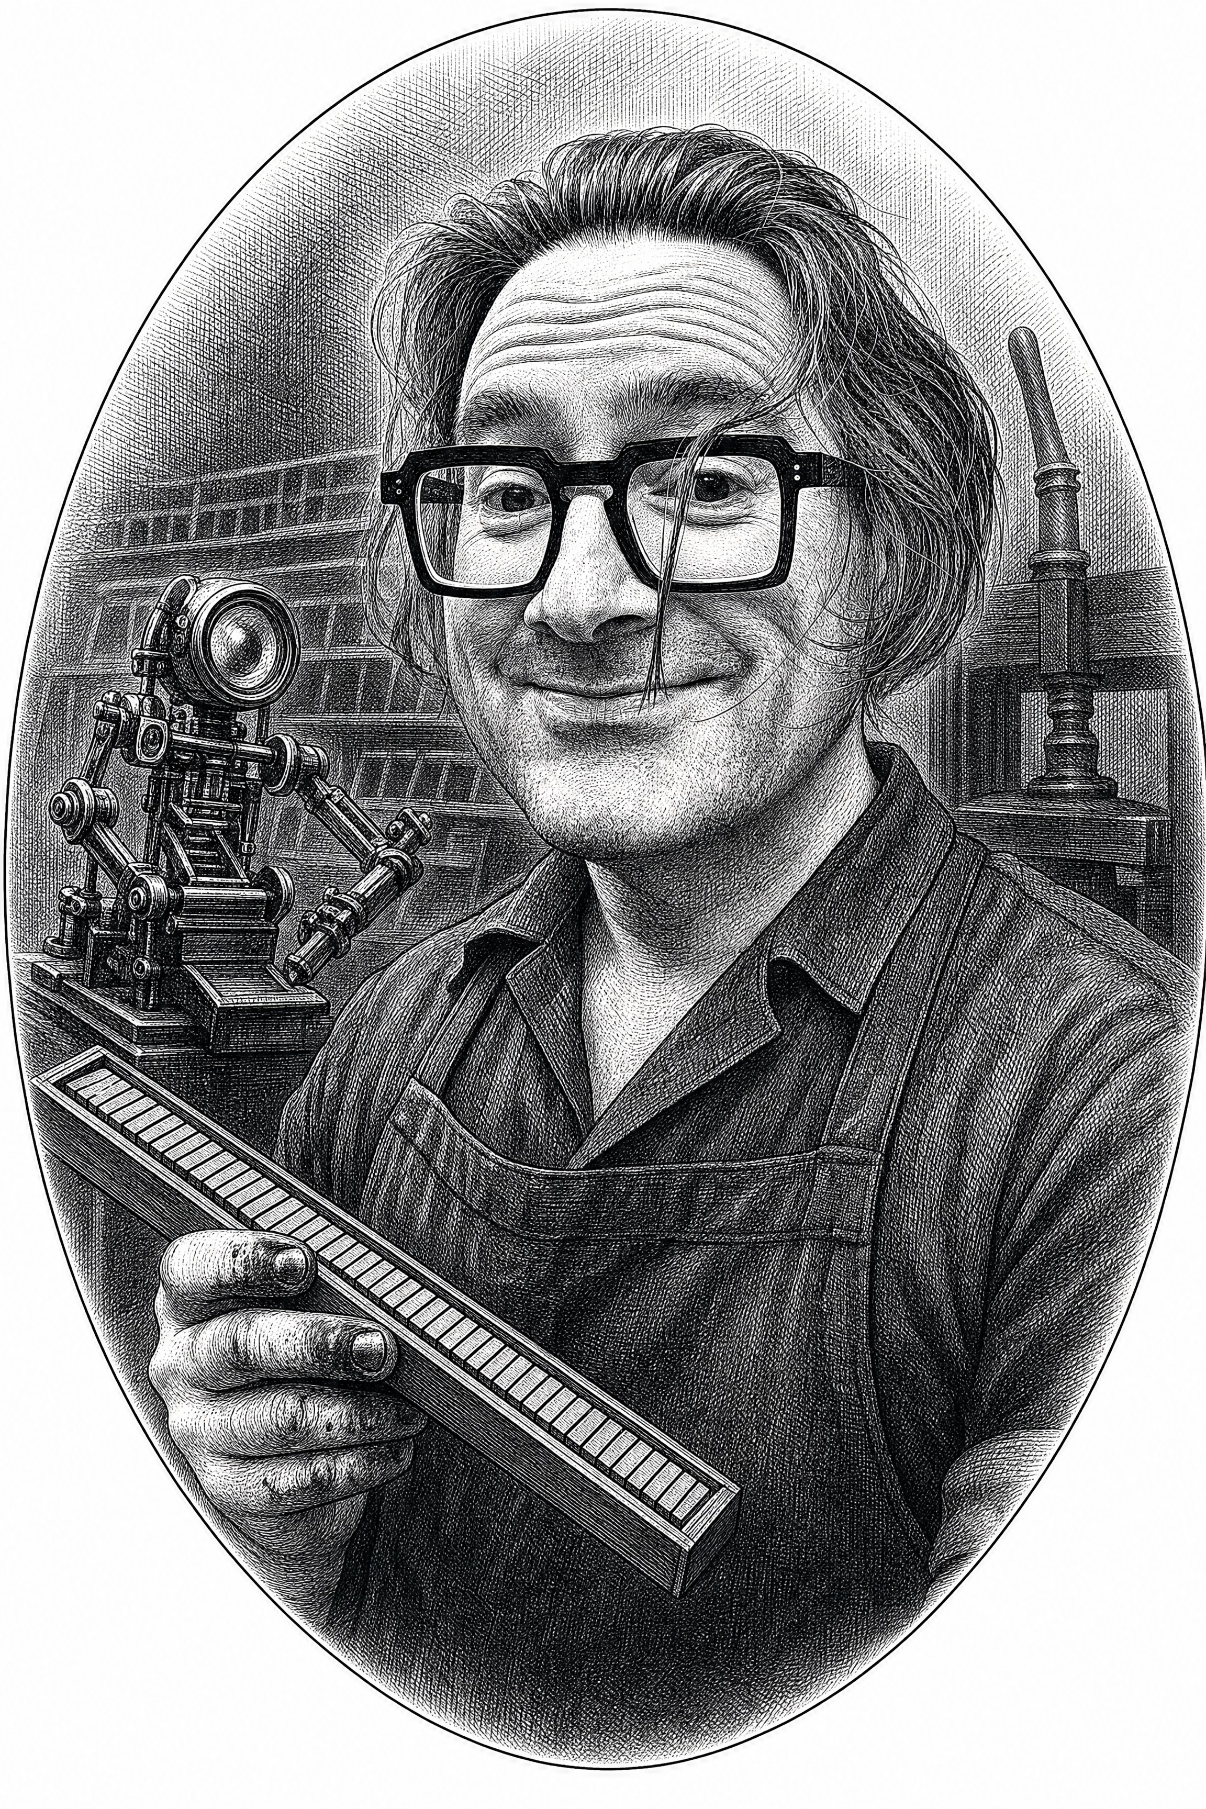
The author, engraved from life.
Clint Ecker keeps a small press in Chicago. He has written software for a long time and now writes it the way this manual describes: as the proprietor of a shop where several tireless machines do the composing and nothing ships on capacity alone. An earlier volume from the same bench concerns the several conditions under which software may be declared finished; this one concerns the shop that makes such declarations possible.
He can be reached at clint@lgtm.systems, and prefers letters that begin with the exact page on which he is wrong.

Not the first craft to check its own work, mind you. The Royal Mint had been assaying sample coins at the Trial of the Pyx since the thirteenth century. But minting verifies a finished object against a standard; printing had to verify a process fast enough to outrun any one inspector, which is the harder and more modern problem, and the one we have inherited.
A compositor short of a letter was, in the trade’s own phrase, out of sorts. The mood and the shortage share the word, and anyone who has watched a build swallow a missing glyph in silence will recognize the feeling.
This was always a fine-press courtesy rather than common practice. Most hand-press colophons named the master printer and the publisher and let the compositor go unrecorded, which is its own quiet argument for writing the credit down yourself.

